Sean Annis  Owner  Eddie Rogers Brewmaster  Rebecca Hei Marketing & Events Manager  Info@northwoodsbrewpub.com  715.597.1828
  Osseo, Wi 54758
  Valued Northwoods Brewing Partner
  Dear Valued Northwoods Brewing Partner,
  Northwoods Brewing would like to thank you for working with us on co-branding a custom beer for your organization. While working with us you, we will help you create a product that will fit most of your supporter’s pallets. We will help you create a custom can design that not only showcases your organization but also a design that your customers will want to collect. By creating this we hope to help you gain excellent exposure and an alternate way to advertise.
  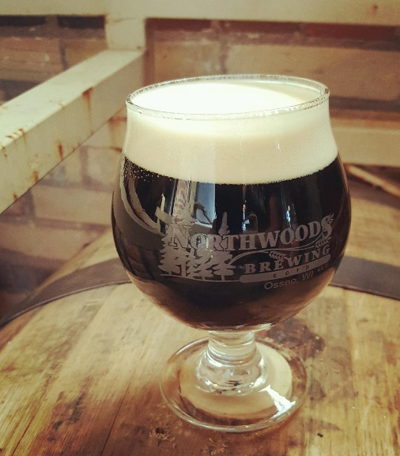
  Sincerely,
  Sean Annis Owner Eddie Rogers Brewmaster Rebecca Hei Marketing & Events Manager

