7th Annual Craig Martin Legacy Youth Duck Hunt
On September 15th, 2018 four area youth were introduced to duck hunting by members of the Southwest Wisconsin Chapter of the Wisconsin Waterfowl Association. The participants were invited out to the Duck Inn Lodge where they learned about local duck species, duck hunting methods, and gun safety. The afternoon’s activities included lunch catered by Huckleberry’s Restaurant, a clay pigeon shoot in a variety of duck hunting situations, and a duck hunt in the Wisconsin River bottoms. Before the hunt, each youth hunter was given a hunting bag filled with hunting supplies and other goodies purchased with funds donated by the Carolyn M And Leary E Peterson Family Foundation Inc. After the hunt, one lucky youth hunter, Teagan Radloff, was drawn as the winner of a Stoeger® Model P3000 12 Gauge pump shotgun which was donated by Tom Olson of Big River Campground. Special thanks to the Nate Cejka and the entire Cejka and Yeomans families for hosting the event at the Duck Inn Lodge!
This event was sponsored by the Craig Martin Legacy Fund which was created to keep Craig’s efforts with youth in the outdoors alive and well after his passing in 2012. Over the years this fund has received generous donations from the Carolyn M and Leary E Peterson Family Foundation Inc., Mark Forsythe of Peoples State Bank, Steve and Angie Jones of Jones’ Black Angus, Scott Yeomans of Sports World, Todd Lensing of Flyway Fowling Guide Service, Keith and Jenny Coleman, The Skemp Family of Huckleberry’s Restaurant, Rick Lange Taxidermy, and Tom Olson of Big River Campground. If you would like to make a donation to the Craig Martin Legacy Fund contact Matt Martin at 608-412-1249. Other outdoor related youth organizations needing support can also contact Matt at the same number.
The Southwest Wisconsin Chapter of the WWA would like to thank all Sponsors, Donors, and past banquet attendees for making events like this possible. Wisconsin Waterfowl Association – Dedicated to the conservation of Wisconsin’s Waterfowl and Wetland Resources.
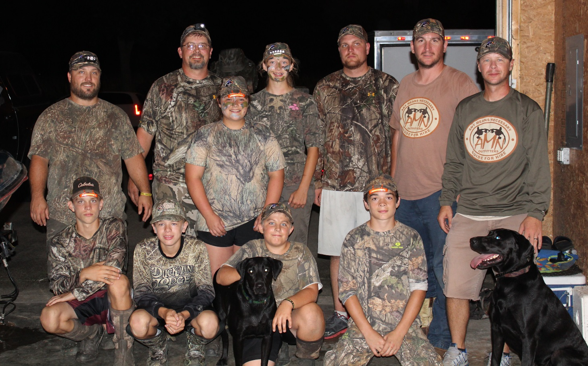
Standing: Mike Pettit, Matt Martin, Kailee Quick, Teagan Radloff, Ryan Deegan, Ryan Stram, and Nate Cejka
Kneeling: Kurt Wall, Maddox Cejka, Birdie, Mikey Pettit, Luke Kramer, Cash
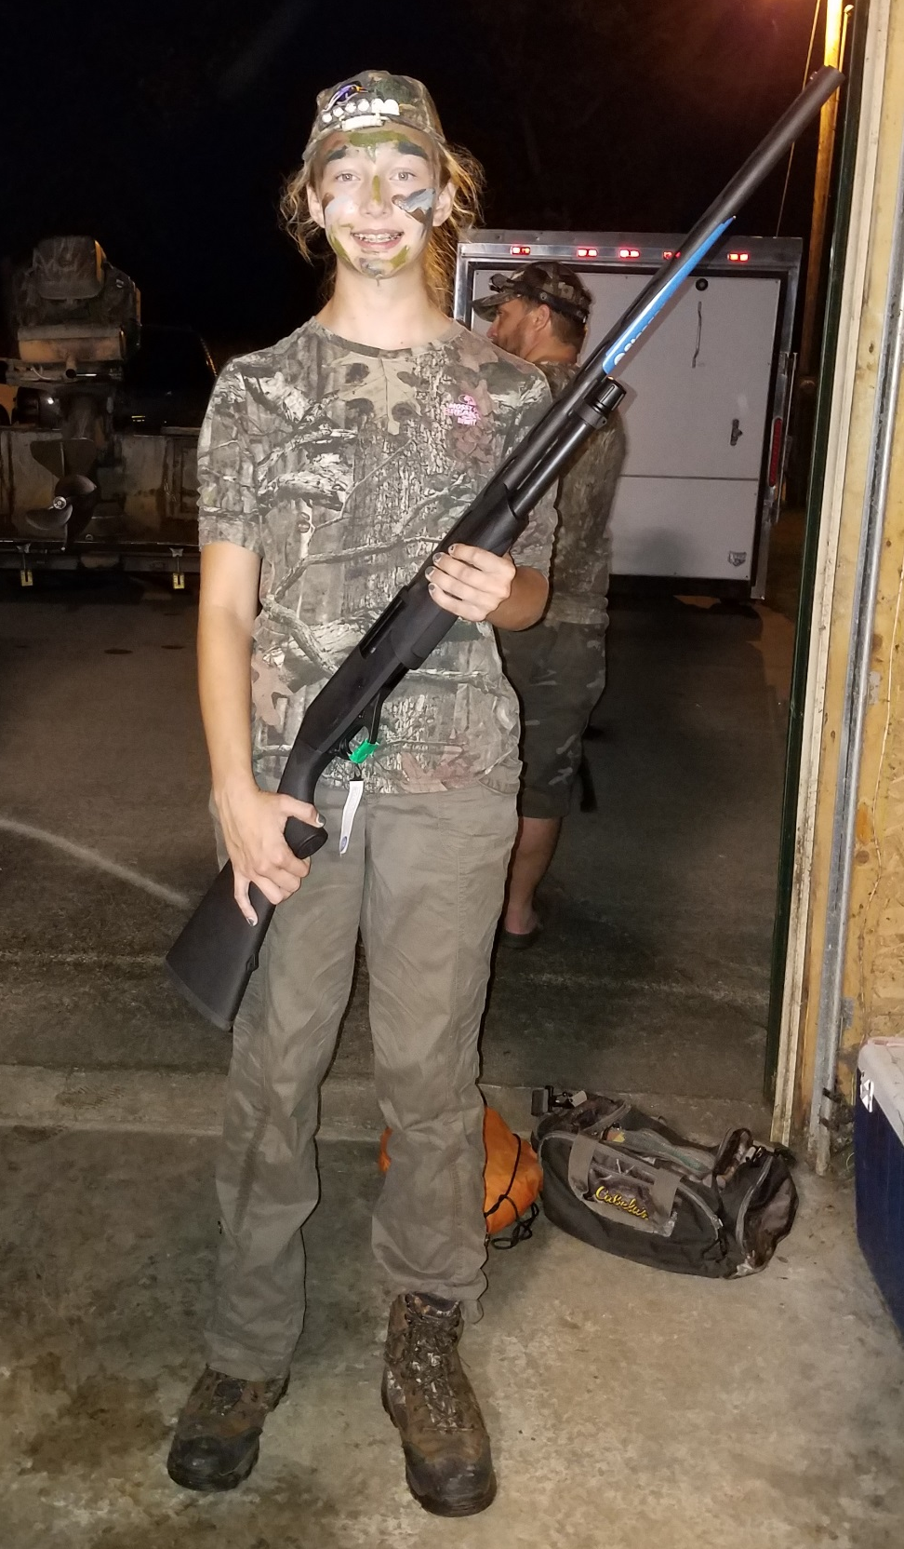

Teagan Radloff with her new gun Donated by Tom Olson of Big River Campground

