9th Annual Craig Martin Legacy Youth Duck Hunt
On September 19th, 2019 four area youth were introduced to duck hunting by members of the Southwest Wisconsin Chapter of the Wisconsin Waterfowl Association. The participants were invited out to the Duck Inn Lodge where they learned about local duck species, duck hunting methods, and gun safety. The afternoon’s activities included lunch catered by Huckleberry’s Restaurant, a clay pigeon shoot in a variety of duck hunting situations, and a duck hunt in the Wisconsin River bottoms. Before the hunt, each youth hunter was provided a hunting bag filled with hunting supplies and other goodies purchased with funds donated by the Carolyn M and Leary E Peterson Family Foundation Inc. and Rick Lange Taxidermy. In addition, Mikey Pettit hand crafted an awesome duck call lanyard for each of the youth hunters. After the hunt, one lucky youth hunter, Cael Koenig, was drawn as the winner of a Stoeger® Model P3000 12 Gauge pump shotgun which was donated by Tom Olson of Big River Campground. Special thanks to the Nate Cejka and the entire Cejka and Yeomans families for hosting the event at the Duck Inn Lodge!
This event was sponsored by the Craig Martin Legacy Fund which was created to keep Craig’s passion for youth in the outdoors alive and well after his passing in 2012. Over the years this fund has received generous donations from the Carolyn M and Leary E Peterson Family Foundation Inc., Rick Lange Taxidermy, Mark Forsythe of Peoples State Bank, Steve and Angie Jones of Jones’ Black Angus, Scott Yeomans of Sports World, Todd Lensing of Flyway Fowling Guide Service, Keith and Jenny Coleman, The Skemp Family of Huckleberry’s Restaurant, and Tom Olson of Big River Campground. If you would like to donate to the Craig Martin Legacy Fund contact Matt Martin at 608-412-1249. Other outdoor related youth organizations needing support can also contact Matt at the same number.
The Southwest Wisconsin Chapter of the WWA would like to thank all Sponsors, Donors, and past banquet attendees for making events like this possible. Wisconsin Waterfowl Association – Dedicated to the conservation of Wisconsin’s Waterfowl and Wetland Resources.
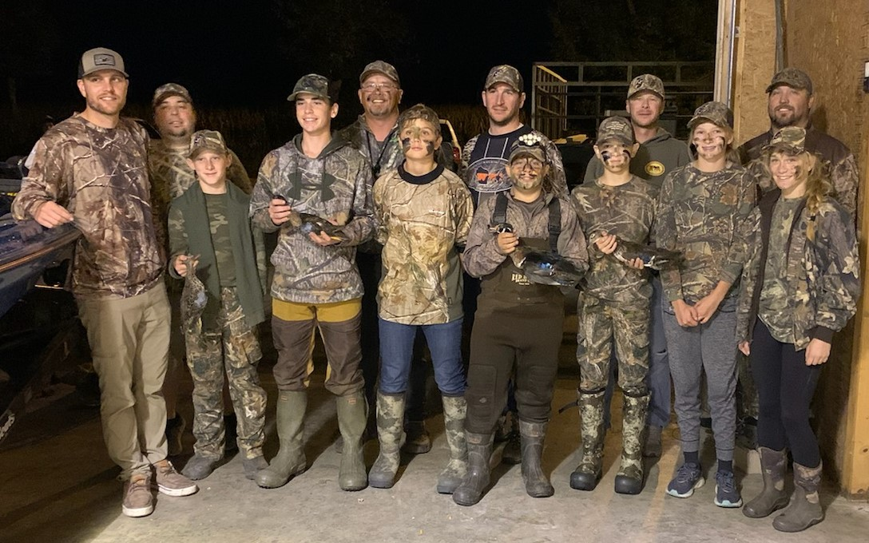
Left to Right: Ryan Deegan, Dylan Varo, Carter Tonne, Jack MacEachern, Matt Martin, Westin Marx, Ryan Stram, Mikey Pettit, Cael Koenig, Nate Cejka, Tannah Radloff, Mike Pettit, Emma Wall

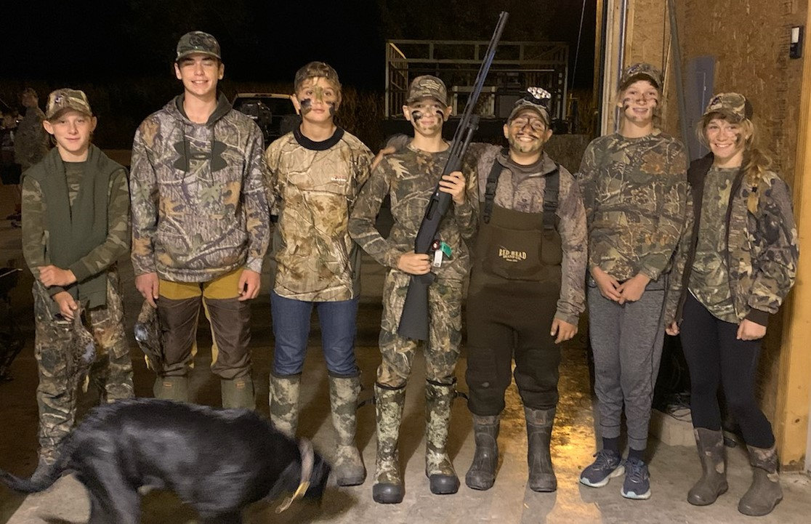

Youth Hunters with Cael Koenig and his new gun Donated by Tom Olson of Big River Campground
L to R: Carter Tonne, Jack MacEachern, Westin Marx, Cael Koenig, Mikey Pettit, Tannah Radloff, Emma Wall

