Waterfowl Hunters EXPO 2022
Sponsorship Agreement
This Sponsorship Agreement (the "Agreement") is made and entered into as of the last signature date below (the "Effective Date") by and between Wisconsin Waterfowl Association with an address of PO Box 427 Wales, WI and the Sponsor identified below ("Sponsor"), collectively referred to as the “Parties”.
Sponsor Name: Luck Duck Premium Decoys, Inc.
RECITALS
WWA is hosting the following event: The 2022 WATERFOWL HUNTERS EXPO and Sponsor desires to sponsor the Event. In consideration of the mutual promises and covenants contained in this Agreement, the parties hereby agree as follows:
1. WWA Obligations. In consideration for Sponsor's participation in the Event, WWA shall provide the Sponsor the benefits set out in Appendix A, which is incorporated and hereby made a part of this Agreement.
2. Sponsor Obligations. For its participation as a Sponsor in the 2022 Event, Sponsor shall pay to WWA a fee (the "Sponsorship Fee"), as selected below:
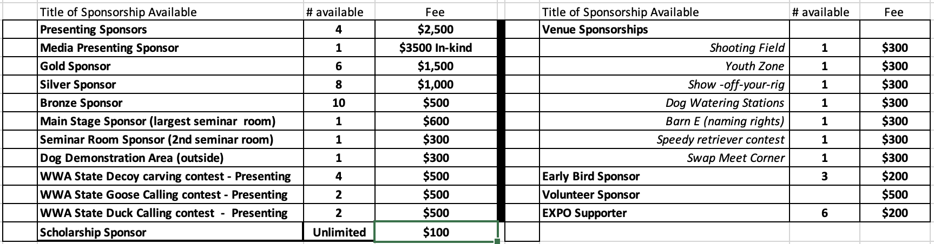
The Sponsorship Fee is payable to Wisconsin Waterfowl Association, due 30 days after date of Agreement signing or agreement is void and WWA cannot guarantee the further availability of desired sponsorship.
3. Sponsor Trademarks/Sponsor Materials. Subject to the terms and conditions of this Agreement, Sponsor grants to WWA the right to use Sponsor's trademarks, trade names, and logo designs and company descriptions as prepared and delivered to WWA by Sponsor (“Sponsor Materials”), in any medium of advertising, marketing materials, and/or promotional goods distributed solely in conjunction with the Event and in accordance with Sponsor's trademark usage guidelines. Sponsor is encouraged but under no obligation to market the EXPO through its digital or traditional media channels. Below are EXPO digital channels for Sponsor use.
- EXPO WEBSITE https://waterfowlhuntersexpo.com
- EXPO FACEBOOK PAGE https://www.facebook.com/WaterfowlHuntersExpo
- EXPO Logo Available upon request
4. Indemnity
4.1 Parties shall not be responsible for any loss of or damage to property of the other Party, its employees, agents, contractors or assigns nor for any personal injury to the other’s officers, directors, employees, agents, contractors and/or invitees except to the extent any such claims may be directly and solely attributable to the gross negligence or willful misconduct of the other Party, its directors, officers, and/or employees.
4.2 Parties shall indemnify, defend, and hold each other harmless from and against any claims arising out of, or relating directly or indirectly to, content on their respective web sites, use of the other’s trademarks and logos, and Materials.
4.3 Parties will give the other prompt written notice of any claim or suit coming within the purview of these indemnities.
5. Limitation of Liability. Except with respect to Section 8.3, in no event shall either party be liable to the other party for any incidental, consequential, indirect, or punitive damages (including but not limited to lost profits) regardless of whether such liability is based on breach of contract, tort, strict liability, breach of warranties, failure of essential purpose or otherwise and even if advised of the possibility of such damages. Notwithstanding anything else in this Agreement, WWA's liability for any claim against WWA shall be limited to the funds available in WWA’s EXPO bank account at the time of the claim.
6. Representations. Each party hereby represents and warrants that it has the full power to enter into and perform according to the terms of this Agreement.
7. Term and Termination
7.1 Term. Subject to the terms and conditions herein, this Agreement shall be effective upon the Effective Date and shall continue through September 4th , 2022--one week past the event date, unless earlier terminated as otherwise provided in this Agreement (the "Term").
7.2 Termination by WWA. WWA shall be entitled to cancel the Event and/or terminate this Agreement at any time for any reason. In the event WWA terminates this Agreement for any reason other than Sponsor's breach WWA shall refund any fees received from Sponsor, and at Sponsor’s expense, return any materials, and equipment, hardware and/or software loaned by Sponsor for the Event.
7.3 Termination by Sponsor; Effect of Termination
a) Sponsor may terminate this Agreement for breach by WWA after giving WWA at least ten (10) days prior written notice specifying the nature of the breach, and giving WWA no less than ten (10) days to cure such breach. In the event such breach remains uncured at the end of the notice period, this Agreement shall terminate on the tenth day. If breach occurs fewer than ten (10) days prior to the Event, Sponsor may terminate this Agreement for breach if such breach is not cured by the first day of the Event.
b) If WWA terminates this Agreement for Sponsor's breach, WWA shall retain any fees received from Sponsor which fees shall be due and payable notwithstanding any such termination. Any equipment, materials and hardware or software of Sponsor shall be returned at the end of the Event and, in the interim, may be used for the purposes contemplated herein notwithstanding such termination.
c) If Sponsor terminates for WWA’s breach, Sponsor shall be entitled to seek a full refund of any fees paid and for the return of any equipment, materials and hardware or software of Sponsor.
7.4 Survival. In the event of termination or expiration of this Agreement, paragraphs 4, 5, 6, 7 and 8 shall survive.
8. Miscellaneous
8.1 Notices. All notices, authorizations and requests in connection with this Agreement shall be deemed given on the day they are (i) deposited in the mail, postage prepaid, certified or registered, return receipt requested; (ii) sent by air express courier, charges prepaid; or (iii) sent by fax as indicated by a fax confirmation sheet; and sent to the address in the recitals. Sponsor agrees to send a copy of any notices, via email to: bross@wisducks.org.
8.2 Relationship. This Agreement does not constitute and shall not be construed as
constituting a partnership, or joint venture relationship between or among the parties.
8.3 Confidentiality. Each party expressly undertakes to retain in confidence all information and know-how transmitted to it by the other party that the disclosing party has designated as proprietary and/or confidential or that, by the nature of the circumstances surrounding the disclosure, ought in good faith to be treated as proprietary and/or confidential, and will make no use of such information and know-how except under the terms, for the purposes of and during the existence of this Agreement. Each party's obligation under this Agreement with respect to any particular information shall extend to the earlier of such time as such information is publicly available through no fault of the receiving party or five (5) years following termination of the Agreement.
8.3 Governing Law/Jurisdiction. This Agreement shall be governed and interpreted in accordance with the laws of the State of Wisconsin. Sponsor consents to the exclusive jurisdiction and venue of the courts in the State of Wisconsin.
8.4 Assignment. This Agreement may not be assigned by either party without prior written consent of the other party.

9.0. Additional consideration. Consistent with agreement, Sponsor agrees to purchase a sponsorship package designated as Presenting Sponsor, 2 of 4, and as shown in the attached Appendix A “2022 Sponsor Program”.
The following additional consideration is provided by WWA for Sponsor:
In lieu of indoor space, Sponsor shall be afforded an outdoor exhibitor space of at least 25’ (frontage) x 30’(depth) along the access road north of the Main EXPO Hall; Additionally, the Sponsor shall be permitted to place several of its dog crates and a small, self-supporting banner at the entrance to the main stage and the speedy retriever contest_________and no others.
The parties have executed this Agreement as of the date set out below:
(SPONSOR)
Corporate Sponsor Name: _____________________________________________________________
Signature: ____________________________________________________________________________
Print name and title:__________________________________________________ __________________
Date: _______________Contact phone & email: _____________________________________________
WWA
Signature: ___________________________________________________________________________
Print name and title:__________________________________________________ __________________
Date: ________________________________________________________________________________
Send checks with this signed agreement, made payable to “Wisconsin Waterfowl Association”

Waterfowl Hunters EXPO
℅ Wisconsin Waterfowl Association, Inc
PO Box 427
Wales, WI 53183-0427

For more information, contact Bruce Ross at 262-389-4999

bross@wisducks.org

Appendix A: 2022 Sponsor Program
