DRAFT Chapter Organizational Review (updated 4/15/2022). WWA INSTRUCTION XXXX

14 April 2022

Subj: CHAPTER CHARTERS AND STATUS TIERS

Maintained by: Administrative Director, Approved by Board of Directors

This current proposal is submitted to the Board of Directors for the purpose of soliciting feedback and guidance, with the intent of finalizing the plan for final approval by the Board in May.

Background: WWA organizes chapters to facilitate grassroots support of its missions and charters each chapter to provide a consistent structure and high-level guidelines. While we have not established a chapter in a while, we have had several chapters drop their active fundraising role. When that happened, many simply folded their tents and stepped away from active volunteering. We have learned recently that at least 2 chapters continued to remain active volunteers, and to some degree, did this under the WWA “banner”. This unsanctioned and un-controlled activity presents a liability and reputational risk.

Historically, charters for such lapsed chapters have not been formally revoked, with the idea that perhaps an influx of new volunteers may re-energize the chapter. This practice creates uncertainty as to legal relationship of the chapter to WWA.

At the same time, changing volunteer motivations may require adjusting our traditional definition of a chapter to something a bit more flexible. Volunteers may be more interested in habitat or education work than a traditional fundraising role. There is organizational benefit to chapters that may eschew traditional fundraising but continue to execute WWA mission work and help maintain a WWA presence in a community. At the same time, all chapters derive benefit from the legal protection, insurance, communication channels, non-profit status etc., of the state-level WWA, and there are some implicit costs in providing that umbrella.

Moving forward, it’ll be important to have adequate chapter controls to ensure compliance with our non-profit mission and legal responsibilities, while at the same time leaving the door open to volunteerism in support of WWA beyond traditional fundraising.

Goal: To develop and implement a chapter organizational scheme that supports the current and anticipated future volunteer opportunities while providing for necessary controls and funding expectations.

Deliverables:
- A short summary of the current state of WWA Chapters and their various activities in support of WWA.
- A tiered chapter status and descriptive policy that ensures adequate chapter controls to mitigate risk to the organization, while allowing for the range of various volunteer effort that may be found in a local community.
- A revised chapter charter that reflects the above
- An implementation plan that for Board approval.

Team: The team looking at these issues includes:
- Ian Bartelmez – (Current or former chapter chair, Director)
- BJ Grassman (Director, Habitat Committee Cahir)
- Dave Elwing (Director, Secretary, Development Committee Chair)
- Dennis Fleishcher (Director)
- Bruce Ross (Executive Director)
Process: The team met ___ times to discuss the expectation and issues, share the results of research and brainstorm concepts. They developed and reviewed a straw man organizational concept and refined that concept. They will share it with key chapter leaders for any feedback they might consider appropriate. .

Overview of results
Original WWA Structure: The original design of the WWA chapter structure, carfted in the 1980’s, mirrored the structure of other non-profit conservation organizations of the day: local chapters focused on fund-raising, and with a state-level board/staff that both supported and was supported by those chapters . Centralized administration of WWA’s non-profit status and management of missions at the state level allowed efficiencies of function.

The original charter for each chapter (attached) was designed and executed to establish each chapter. The charter permitted each chapter to elect officers and establish bylaws as long as they did not conflict with WWA’s bylaws. There were reporting expectations (change of officers, financial report timeliness, etc.) that each chapter was to meet in order to remain in good standing.

Over time, chapters evolved, volunteers came and went, and some chapters disbanded. Chapter reporting expectations were ignored without consequence. The list of current chapters and their activities (attached) was created based on our collective knowledge, not the result of chapter reporting per the charter’s expectations. These uninspiring practices has created avoidable liabilities for WWA.

At the same time, it’s clear that volunteer motivations are evolving. Volunteers increasingly seek to deliver a hands-on impact from their volunteer time, and not simply raise money for organization. WWA’s organizational model of the last century may no longer be the best model for this century. We have the opportunity to define an organizational structure to meet these evolving interests.

Important factors.
Any new chapter structure (or design) should:
- Attract the wide range of volunteers committed one or more of WWA missions in a given geographic area.
- Make it easy for chapters to form from a handful of volunteers committed to one or more of WWA’s missions.
- Incentivize chapters to expand their volunteer effort across the range of mission activities.
- Recognize chapters with higher levels of mission engagement and financial success
- Require sufficient fundraising to offset state-level overhead costs, and incentivize higher levels of financial support for greater mission impact.
- Be compatible with the ‘recently’ established Board committee structure, to the degree reasonable.

It may be possible to estimate the marginal costs of state support of a chapter. But that analytical effort would be subject to broad assumptions, tenuous allocations, and vague estimates. Conducting that analysis was not deemed worthwhile for this project. However, the team acknowledges that there are overhead costs involved in supporting field level activities that number in the thousands of dollars, including insurance, staff time, travel, communication, maintenance of our non-profit status and others. And beyond overhead costs, there are costs associated with executing WWA mission set of habitat, education and advocacy.

Proposed tiered Status
The hierarchy of chapters shown below links financial performance and mission engagement with levels of “benefits”. It is intended to allow newly forming chapters (i.e., “probationary”) a low entry threshold of financial contribution sufficient to offset some state-level overhead while allowing them to benefit from WWA’s organizational status and resources.

Probationary status is not intended to become a semi-permanent status for a chapter but simply an entry point. It also could represent a temporary status for a pre-existing chapter that is going through a period of reorganization.

The higher tiers (“associate” and “premier”) recognize a chapter’s greater financial contribution with greater benefits. Determination of each chapter’s status would happen at the end of a WWA fiscal year based on their net financial results and participation in WWA mission activities of that year. Designation of a chapter into any category would be determined by the Administrative Director, and approved by the Development Committee.

As we gain experience with this new methodology, the benefits and requirements for each status may undergo change over time, subject to Board approval. A newly drafted chapter charter (attached) will contain a general description each chapter status, but not contain the specifics that may be subject to change. The Development Committee, with assistance from the Administrative Director will be responsible for updating this policy guidance.

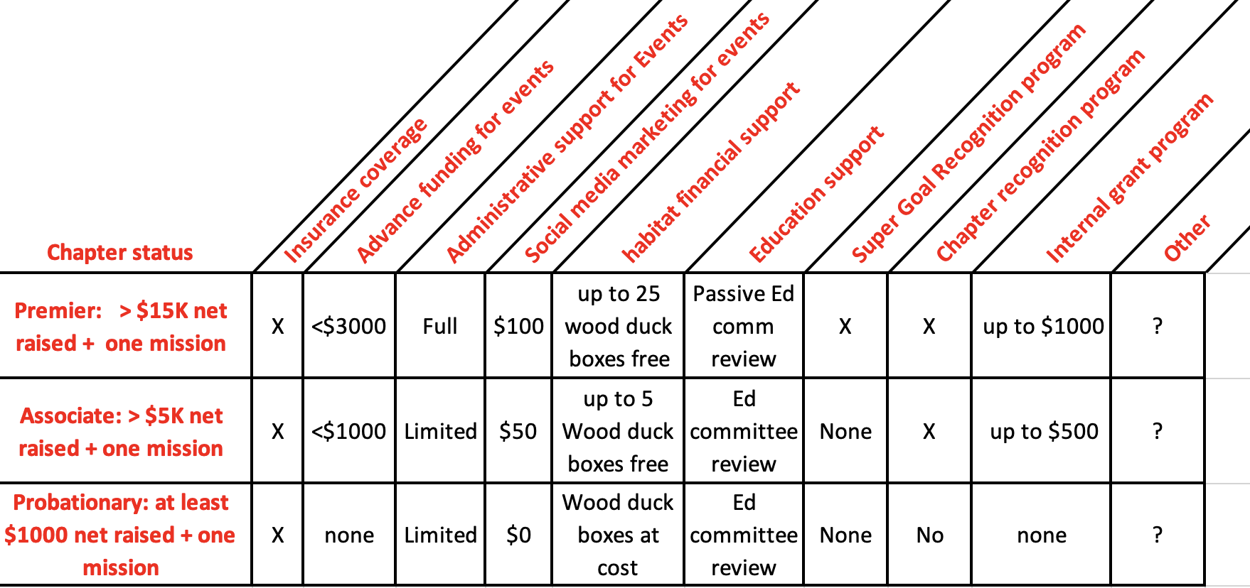

Implementation plan:
- April 2022: The project team will consider Board feedback from the April board meeting and adjust this document as needed, then
- May: Send it out to existing chapters (including those that have “slipped from the WWA fold” but have unrevoked charters). Any feedback will be considered and incorporated, for final approval at the May 2022 Board of Director’s meeting.
- June: After approval, this proposal will be converted into an instruction and incorporated into WWA chapter webpage. Implementation will be effective immediately. Each chapter will be notified of its existence and presented with the new charter for signature and return to WWA’s Administrative Director.
- July: New charters and tiered status will be in effect.

Attachments:
(1) List of current chapters and activities
(2) Strawman template of possible Chapter tiers (by way of example)
(3) Current WWA Charter

Attachment (1): List of current chapters and activities

Chartered Chapters | Banq | Bash | Shoot | Golf | Class A | Calendar Sales | Mission-work | No Activity
Appleton/Valley | 1 |  | 1 |  | X | X | AWA
Baraboo River |  | 1 |  |  | X | X
Green Bay | 1 |  | 1 |  | X | X | AWA, LTH
Waukesha | 1 | 2 |  |  | X | X | AWA
So Suburban | 1 |  |  |  | X | X | LTH
State |  |  | 2 | 2 | X | X
West Allis | 1 | 1 | 1 |  | X | X | AWA
Madison (?) |  |  |  | 1 |  | X | AWA
Cedar Creek |  |  | 1 |  |  | X | AWA
West bend | 1 |  |  |  | X | X | ?
Lakeshore | 1 |  |  |  |  | X | ?
Wausau |  |  |  |  |  | X
Prairie du Chien |  |  |  |  |  |  | Youth hunt
Others… TBD

Attachment (2): Original WWA Chapter Charter


WISCONSIN WATERFOWL ASSOCIATION

HABITAT EDUCATION LEGISLATION
p.o. bOX 427 • WALES, WI • 53183-0427
Phone: 262-968-1722 • Fax: 262-968-1723
www.wisducks.org • wwainfo@centurytel.net

CHAPTER CHARTER

A group of members in good standing, representing __ City/County have made application and are hereby granted a Charter designating such a local chapter of the Corporation, known as the _____________________Chapter of the Wisconsin Waterfowl Association, hereafter referred to as the Chapter. This Charter is issued under authority of the Board of Directors of the Corporation. The Chapter may elect officers, subject to the control of the Corporation’s finance operations, and establish rules and bylaws so long as these operations do not conflict with the Articles, Bylaws or purposes and policies of the Corporation.

The Chapter shall be required to maintain a current list of names and addresses of each officer and member of the Chapter, and file an accurate and complete copy of said list with the Director of Administrative Services at the State Office immediately following organization, and each calendar year thereafter. The names and addresses of any new members acquired by the Chapter shall immediately be turned over to the State Office.

The Chapter so organized and chartered shall at all times maintain accurate financial records and file a report of same no later than 30 (thirty) days following each fundraising activity. All monies collected by the Chapter shall belong to the Corporation subject to payment of all obligations incurred by the Chapter and approved by the Corporation.

The Board of Directors of the Corporation may, for just cause, terminate this Charter, but, in such event, the members of the Chapter continue to be members of the Corporation so long as such members continue to pay dues to the Corporation. The Corporation shall maintain supervisory control of the Chapter, and in the event that conflict arises between policies of the Corporation and the policies and procedures of the Chapter, the Board of Directors is charged with the duty to resolve such conflict. In the event the Chapter is terminated, the Chapter must immediately remand any assets, and all records held in the name of the Association to the WWA State Office.
For the Wisconsin Waterfowl Association:

________________________________ Title: Chapter Chairperson Date: ___________________

____________________________ Title: Executive Director Date: ___________________

The Wisconsin Waterfowl Association is a non-profit, wildlife conservation organization. The Association is exempt from Federal Income Tax as an organization described in Section 501 (c) (3) of the Internal Revenue Code. Contributions made to the Association are deductible provided in Section 170 of the Code. The Association’s F

Attachment (2): Proposed WWA Chapter Charter

WISCONSIN WATERFOWL ASSOCIATION

HABITAT EDUCATION LEGISLATION
p.o. bOX 427 • WALES, WI • 53183-0427
Phone: 262-968-1722 • Fax: 262-968-1723
www.wisducks.org • wwainfo@centurytel.net

DRAFT___CHAPTER CHARTER (rev: June 2022). DRAFT

- Establishment of this Chapter. A group of members in good standing, representing _______________________ City/County have made application and are hereby granted a Charter designating such a local chapter of the Corporation, known as the _____________________Chapter of the Wisconsin Waterfowl Association, hereafter referred to as the Chapter. WWA organizes chapters to encourage grassroots support of its missions, and it charters each chapter to provide a consistent structure and provide clear expectations.
- Authority. This Charter is issued under authority of the Board of Directors of the Corporation. The Chapter may elect officers, subject to the control of the Corporation’s finance operations, and establish rules and bylaws so long as these operations do not conflict with the Articles, Bylaws or purposes and policies of the Corporation.
- Responsibilities. Both the Chapter and the Corporation have obligations under this charter.
  - The state-level organization shall be responsible for:
- Maintaining WWA’s non-profit status
- Providing administrative support at the state level
- Maintaining WWA communications is support of fundraising and mission accomplishment
- Using raised funds efficiently in support of accomplishing WWA missions
- Carrying insurance to cover known chapter and corporate liability exposures.

  - The Chapter shall be responsible for:
- Conducting fundraising activities consistent with WWA policy and state law
- Conducting any local mission-related efforts consistent with WWA policy and guidance
- Reporting leadership and membership changes each year consistent with WWA policy
- Strict compliance with federal, state laws and compliance with WWA policies for any funds raised under WWA’s non-profit status
- Timely reporting of chapters activities and fundraising consistent with WWA policies.
The Chapter shall at all times maintain accurate financial records and file a report of same no later than 30 (thirty) days following each fundraising activity. All monies collected by the Chapter shall belong to the Corporation subject to payment of all obligations incurred by the Chapter and approved by the Corporation.

- Categories of Chapters. The Corporation may annually categorize each Chapter based on the missions they perform at the local level and the level of fundraising activity they undertake. Depending on which category this Chapter falls into will determine the level of benefits available to that chapter. See current WWA policy with regard to these categories and their benefits.
  - The lowest category “probationary” status applies to chapters that do not achieve the minimum level of fundraising necessary to fully offset the Corporation’s overhead costs of supporting that chapter. No chapter will be considered in good standing if they remain in a category of “probationary” status for an extended period of time as determined by the Board of Directors.
- Supervision of Chapter. The Corporation shall maintain supervisory control of the Chapter, and in the event that conflict arises between policies of the Corporation and the policies and procedures of the Chapter, the Board of Directors is charged with the duty to resolve such conflict. In the event the Chapter is terminated, the Chapter must immediately remand any assets, and all records held in the name of the Association to the WWA State Office.
- Termination. The Board of Directors of the Corporation may, for just cause, revoke this Chapter’s Charter, but in such event, the members of the Chapter continue to be members of the Corporation so long as such members continue to pay dues to the Corporation.

For the Wisconsin Waterfowl Association:

____________________________ Chapter Chairperson Date: ___________________

_______________________ Executive Director Date: ___________________

The Wisconsin Waterfowl Association is a non-profit, wildlife conservation organization. The Association is exempt from Federal Income Tax as an organization described in Section 501 (c) (3) of the Internal Revenue Code. Contributions made to the Association are deductible provided in Section 170 of the Code.

