Wisconsin Waterfowl Association
Annual Report
2021

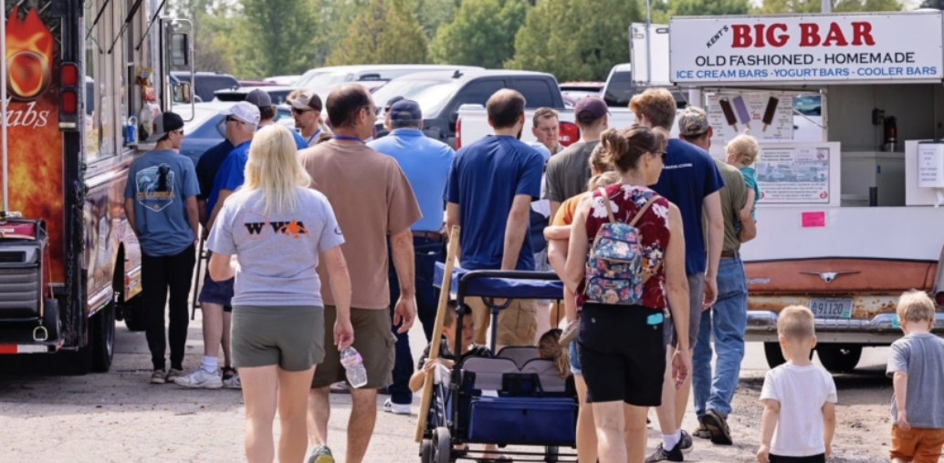
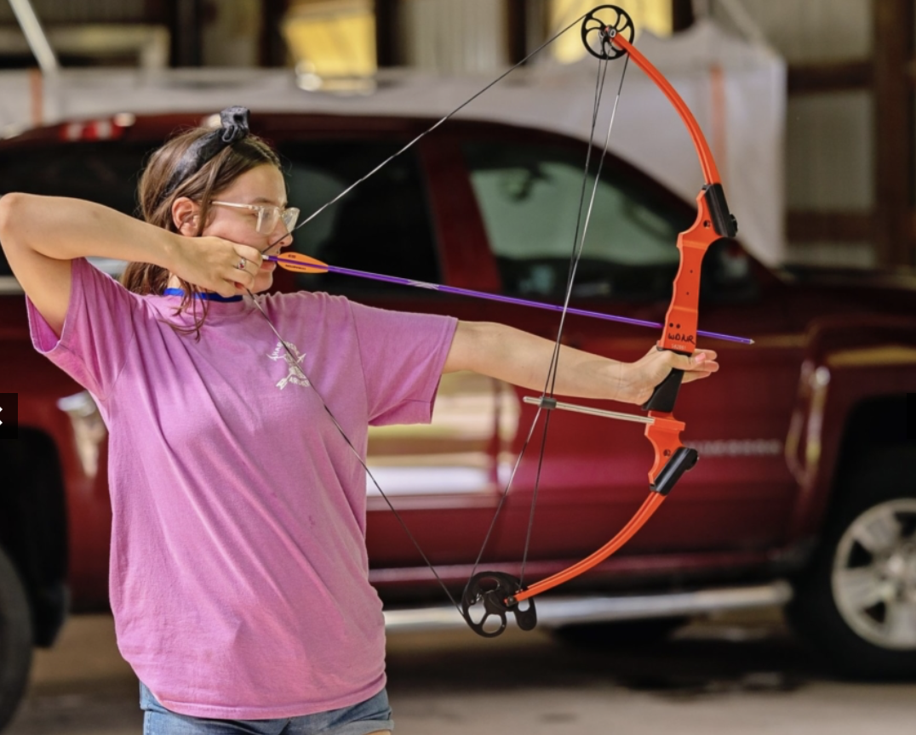
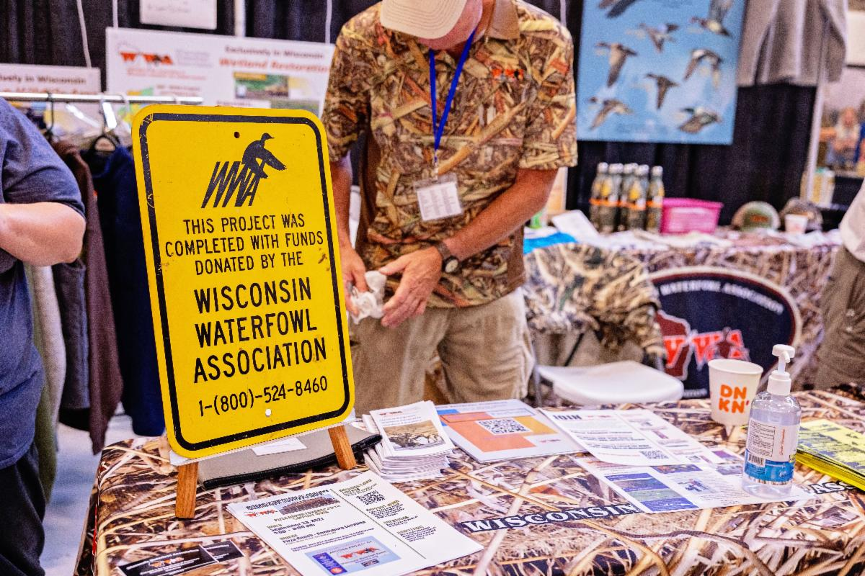
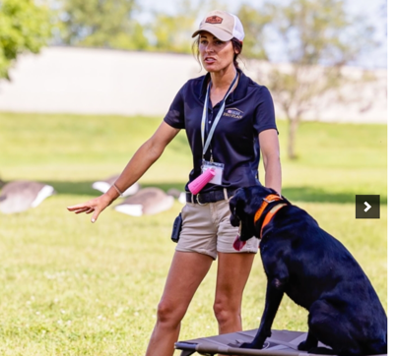

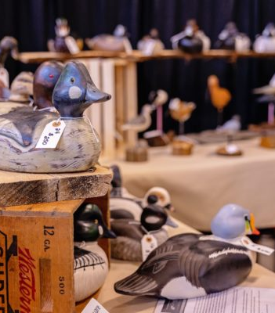
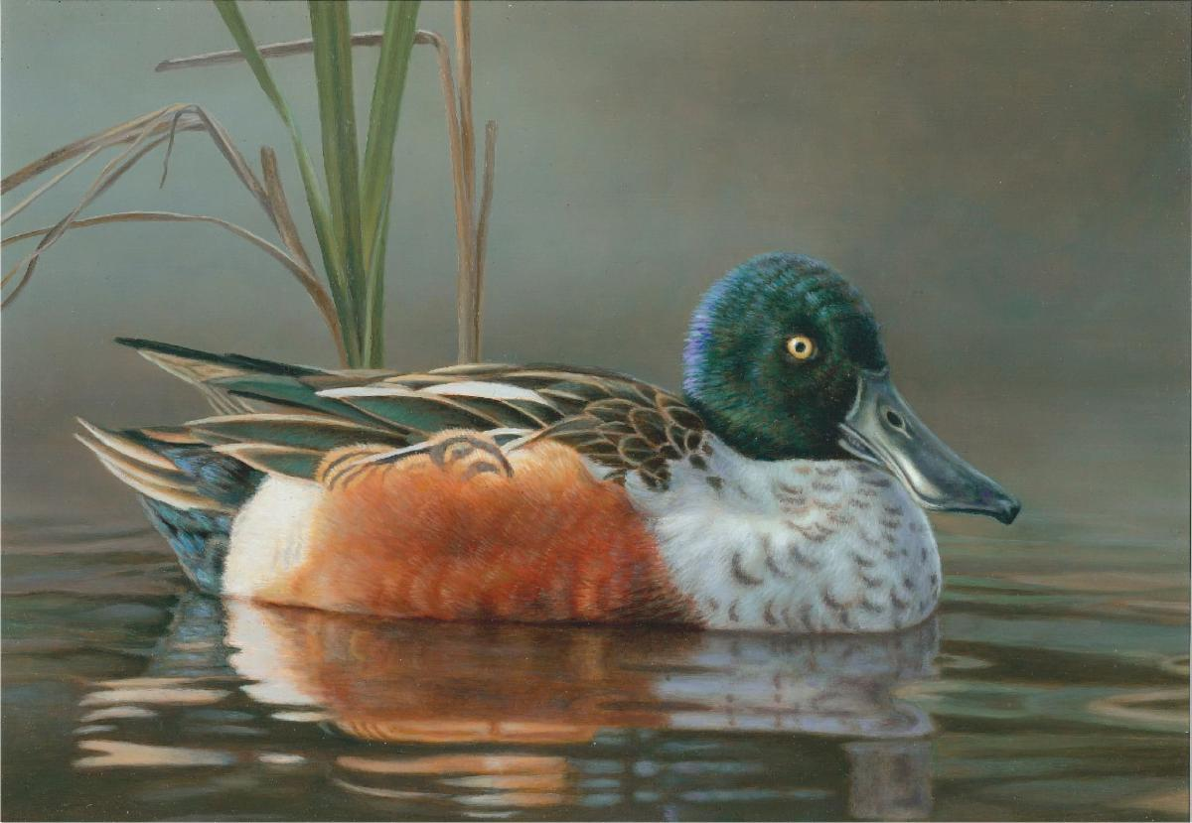
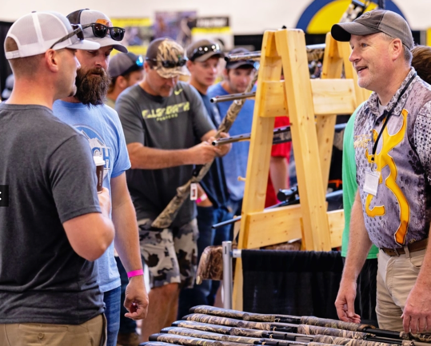
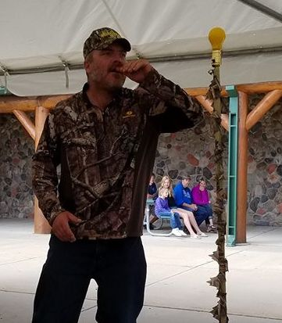
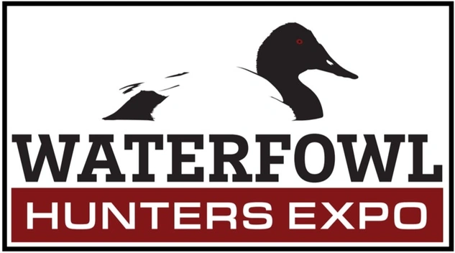
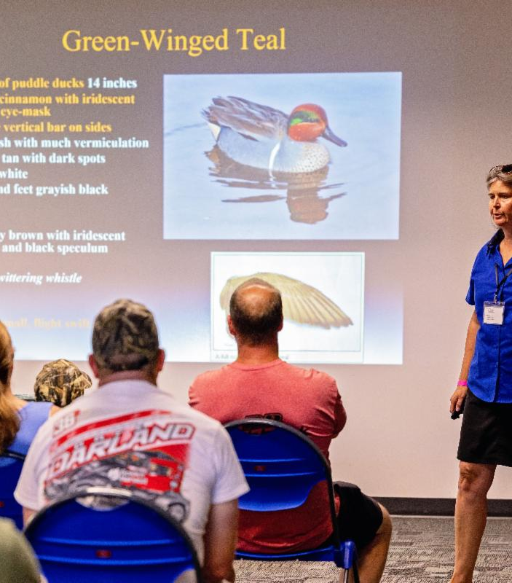
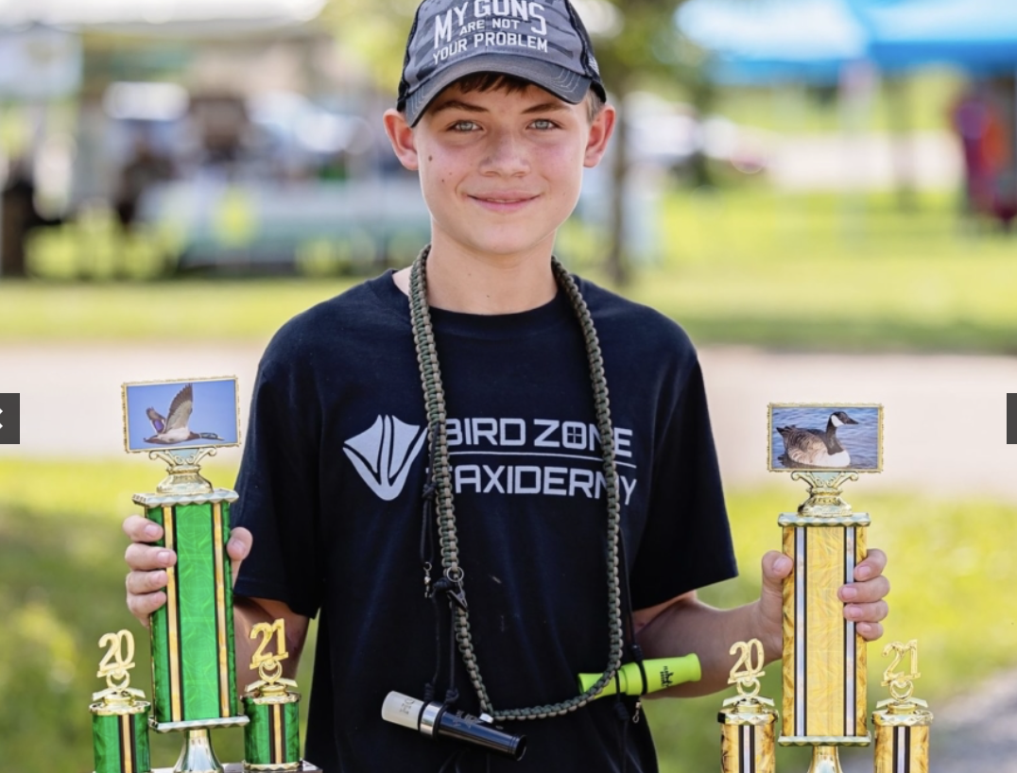
WWA 2021 Annual Report

Letter from the President of the Board

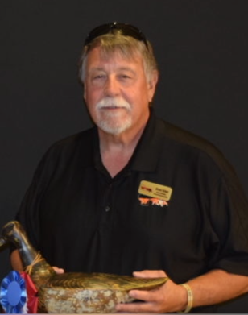
I’m pleased to present WWA’s Annual Report. It is filled with information about the efforts of WWA to support the interests of Wisconsin Waterfowlers in 2021. And despite the pandemic, it was a great year. Grassroots fundraising knocked it out of the park, with exceptional financial results for each and every event. Volunteers stepped up in ALL of WWA’s mission areas and corporate supporters flocked to WWA and its inaugural Waterfowl Hunters EXPO. And habitat work that had been slowed by pandemic implications, has begun to accelerate—both the do-it-yourself kind by volunteers and by our professional ecologist. Thanks for being part of the WWA team!

Bruce Urben
Bruce Urben
President, WWA Board of Directors

Letter from the Executive Director

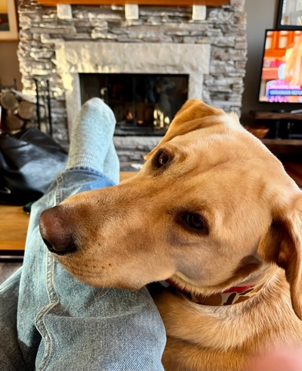
Some of you may know I acquired a new retriever—Tack—in late 2020, with the highest hopes of it being my best hunting companion ever. And of course, in very short order. As Tack enters his second year of training, he makes a point of reminding me that such achievements require time—plus many other attentions.

But we are pleased to report that seeds planted by the board of directors only two years ago, with time, plus energized focus, and more than a little good fortune yielded significant fruit in 2021. This annual report celebrates those achievements without shying away from the challenges and risks ahead as we work to build an ever more impactful organization for the state’s waterfowlers.. New initiatives like the Waterfowl Hunters EXPO and the state committee structure, coupled with a new financial stability and corporate sponsorship should help us keep the ball moving down field in the years ahead.

Bruce (and Tack!)
Bruce Ross, Executive Director

Wisconsin Waterfowl Association’s 2021 Annual Report

The Wisconsin Waterfowl Association celebrated its 37th year in 2021. Notwithstanding the specter of the coronavirus pandemic that loomed over the state, nation and world, 2021 proved to be a positive inflection point for the organization’s financial and mission effectiveness.

2021 highlights include:
- All local chapters exceeded fundraising goals while achieving noteworthy habitat results;
- The Better Business Bureau validated WWA non-profit management practices and accounting; and
- WWA led state waterfowling organizations in establishing the pre-eminent gathering of the state’s duckhunters.
- Habitat efforts that had been slowed by pandemic impacts accelerated and were boosted by volunteer efforts to grow the number of acres we can restore
- More effective marketing and greater involvement in important state happenings gave WWA greater visibility
- Long-standing legislative goals were finally achieved.
- Chapter fundraising success, government help, and operational efficiencies allowed us to close 2021’s financial books in our best financial condition in over a decade.
In aggregate, WWA is organizationally and financially positioned to make strategic investments that will accelerate the results we deliver for the state’s waterfowlers. These will be important as we grow our pandemic-impacted restoration efforts, address known challenges, and face an uncertain economic future.
WWA Mission
The 37 year-old Wisconsin Waterfowl Association
- Restores and conserves Wisconsin’s waterfowl and wetland resources,
- Educates state waterfowlers as they progress from natural resource consumer to steward; and
- Promotes governmental policies that protect Wisconsin’s resources and uphold the rights of citizens to hunt.

This 2021 Annual Report walks the reader through the 2021 results delivered in each WWA mission area, then focuses on organizational topics, before concluding with financial results.

POLICY: Promoting policies that protect Wisconsin’s resources and uphold the rights of citizens to hunt

Increasingly fewer state and federal policy makers have outdoor backgrounds. Without WWA advocating for both conservation AND hunting concerns, who will?

WWA’s policy team represents a remarkable collection of policy experience: a former state senate majority leader, a former DNR executive, former DNR chief warden, a professional state lobbyist, and a strong complementary cast. The team has high energy, strong experience, and together with grassroots support, notched the most WWA policy wins in decades.

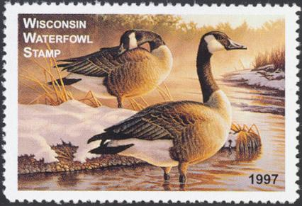
For decades, waterfowlers have done the things necessary to earn the respect of policy-makers and the public as responsible users of the state’s resources. We give more back to our community and the environment than we take. Period. There is no better example than our efforts to raise the price of the state’s Waterfowl Stamp.

A Policy Success 10 Years in the Making
Despite overwhelming hunter support, Wisconsin’s duck hunting organizations had struggled for nearly a decade to convince legislators to adjust the state duck stamp for inflationary erosion since 1997. With a new state budget cycle, and greater insight to the politics involved represented in our Policy Committee, WWA devoted significant effort to finally getting it across the goal line in 2021. The stamp increase from $7 to $12 means stamp purchases will result in nearly $400,000 additional dollars per year dedicated to wetlands work. This additional funding, when leveraged against other private, federal and corporate funds, will yield nearly $2 million annually towards wetland work that directly benefits Wisconsin waterfowlers and the communities served by the wetlands this funding restores.

Other policy initiatives.
Knowles-Nelson Stewardship program.
Simultaneously with the duck stamp, WWA weighed in on the pending re-authorization and funding of the 40-year-old Knowles Nelson Stewardship program. This program is Wisconsin’s biggest conservation funding engine but had been foundering for several years without long term re-authorization and insufficient funding. Duckhunters and other outdoorsmen and women would have been hurt if this status quo was allowed to continue. As part of a broad coalition of conservation groups, WWA’s voice at the capital was important to convincing legislators of the value of this program, leading to its reauthorization at an acceptable funding level.

Open Water Zone – a unique season for this unique duckhunting environment
WWA Policy Makers of the Year

Policy makers on both sides of the aisle agreed that without BOTH of these politicians WWA’s two critical policy initiatives—increase the duck stamp fee, and re-authorize the Knowles-Nelson Stewardship fund—would not have happened. So it was fitting that WWA selected BOTH policy-makers for its inaugural award.

<<pics of Born and Evers receiving award>>
Based on membership input, WWA had been a key proponent of adjusting the three allowable Wisconsin duck hunting zones to consider the offshore waters of Lake Michigan. This environment that features seaducks and wide expanses of open water, requires layout boats, and heavy weather equipment, can offer a unique experience for the state’s waterfowlers. WWA worked with the DNR to shape this significant change to the state’s season structure that was implemented inn 2021.

Sandhill crane hunt – not ready for prime time
Wisconsin’s sandhill are nearly ubiquitous, exceeding state wetland carrying capacity needed for reproduction. Now common on golf courses and backyards, sandhills are increasingly taking a significant financial toll on farmers--$1.6 million in 2019 and growing with the SHC population. Ten years ago, a legislative effort to introduce a USFWS-authorized SHC hunt never saw a committee vote. The SHC’s nearly exponential population growth, and the fact that 17 other states authorize such a hunt will keep the possibility of a Wisconsin hunt in the news.

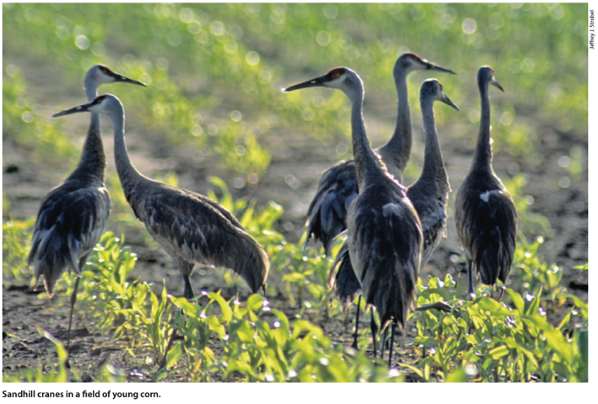
Recognizing it would be a controversial topic, WWA initiated an educational series of articles on the background, science and relevant issues and worked to engage organizations that would likely fall on the other side of the question. Unknown to WWA, legislators planned to introduce crane hunt legislation late in the session, with a package of other outdoors-related initiatives called the sporting freedom package. Although the SHC bill saw a party-line vote in the relevant Senate committee, it failed to advance before the close of session. Nevertheless, WWA worked very closely with the bill’s authors, educating as needed and making significant improvements to the bill so it will be ready for when the effort will gain more traction in the future. WWA recognizes that a SHC hunt (like the earlier dove hunt) will not be universally supported across the state, but consistent with our mission, believes the issue should be decided on the science, not the emotional perspective of anti-hunters.

HABITAT: Restoring and conserving waterfowl and wetland resources.

Private land restorations.
WWA uses fundraising events to fund our ecologist (who manages our program), survey and design wetland projects, submit permits and gather grants to help fund the rest of each project. Federal state and private foundation grants help pay for contracted excavation and other water con troll, materials, while landowners and other partners help defray these costs. Historically, less than $300 of WWA funds can be leveraged against other sources of funds to complete one acre of wetland restoration.
WWA Habitat Headwinds
Despite nearly 75% of the state wetlands being held by private landowners, it remains a challenge to find the right restoration projects. Why?

- The easy projects have already been done--Wisconsin’s low-hanging restoration “fruit” has already been plucked.
- Recent flyway definition of targeted, priority landscapes narrows the statewide opportunities.
- Wetland restorations can be expensive - Landowners often require some financial encouragement to shoulder the significant effort and expense.
- Doing all of the above, at a sufficient scale to contribute significantly to the Wisconsin Waterfowl Management Plan’s goals.
- Pandemic effects in 2020-21 slowed permitting, made contractors more difficult to access, and landowners more challenging to engage.

WWA’s historical focus on private wetland restoration is based on the premise that Wisconsin hunters harvest mostly Wisconsin ducks. And since smaller private wetlands more efficiently support waterfowl breeding, ignoring the 75% of Wisconsin’s wetlands that are private will hurt the state’s waterfowlers. While WWA continues to face strong headwinds (see sidebar), we made significant progress in 2021 to overcome the challenges and put more wetlands on the state’s landscape.

WWA managed three grants during 2021 including one duck stamp grant, and two North American Wetlands Conservation Act (NAWCA) grants, totaling $200,000. Thirteen projects were completed in 2021, which including 7 water control structures, 6 ditch fills/plugs, and 3 scrapes. Over 440 acres were restored under the NAWCA grant completed in 2021.

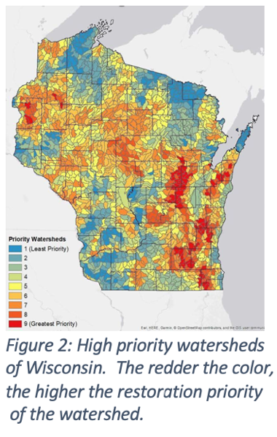
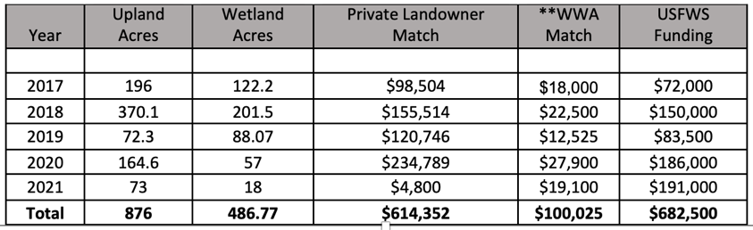
The lingering effects of the pandemic also made themselves felt in the numbers associated with our restoration partnership with the USFWS also. For five years, WWA has partnered with the USFWS to administer grants for some of their state restoration work. Under this partnership, significantly fewer wetland acres were restored. Required permits were slower in arriving while construction companies were more difficult to engage. We are seeing the return to more historic levels of activity as 2022 starts.
Figure 1: Table of partnership restoration efforts with US Fish and Wildlife Service.

For reasons other than the pandemic, 2021 was also a challenging year for our wild rice efforts. Limited wild rice production around the state limited WWA supply, leading to seeding only one area—Collins Marsh in Manitowoc County. During 2021, WWA inked a partnership to become the distribution agent for the state’s wild rice program, using state duck stamp funds, for 2022.

Local habitat projects.
Chapter Adopt-a-wildlife Area-type activities began to rebound after the impact of COVID. Highlights include:
- Over 150 wood duck boxes hung just this year
- Improved logistics led to over 90 sold wood duck boxes – best year ever
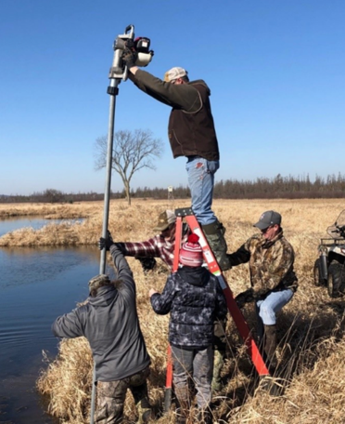
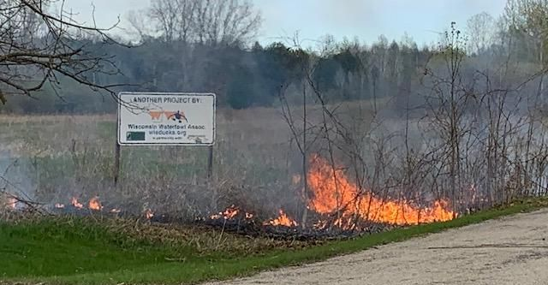
- Mike Alaimo’s black tern nesting platform broadened to include the banding of returning terns for further scientific study.
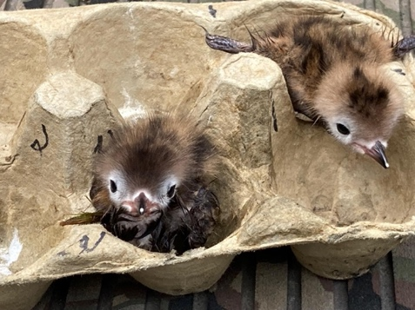
The Waterfowler’s Arc

Waterfowlers progress through phases as they gain more experience. WWA is committed to providing the knowledge and encouragement in that progression from wannabe and newbie to seasoned veteran.
- New waterfowlers want to pull the trigger, to fill their limits; to become technically proficient with the tools of the hunt.
- Journeymen waterfowlers explore how to be more successful by understanding where ducks want to be and why. They begin to cherish the duck hunting experience and camaraderie as much as the harvest.
- With more seasons in the rear-view mirror, well-seasoned veterans focus on how to pay it forward – what role can they play in making sure the next generation has the opportunity to be shaped by these outdoor experiences?
This progression was epitomized by Erich Pitz, longtime patron of our wood duck box program. Erich passed in 2020 and was inducted into the WWA Hall of fame in 2021.

EDUCATION: Encouraging state waterfowlers as they progress from natural resource consumer to natural resource steward.

Learn to Hunt Waterfowl programs.
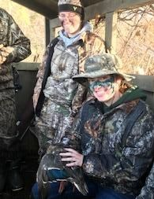
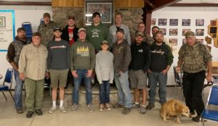
The Green Bay Chapter continued its long-running learn-to-hunt waterfowl program in 2021, giving nine new waterfowlers a quality waterfowling experience. Participants ranged from a 60-year-old first time hunter to a 20-something participant and a youth aged 12.

Prairie du Chien chapter held its 7th annual youth hunt that introduces young hunters to waterfowling. 13 kids got their first taste –literally—of ducks at this well-received program.
WWA Member Newsletter
WWA’s monthly newsletter continues to be Wisconsin’s premier communication focused on state waterfowling issues. Averaging 6 authors and 11 articles per month, this digital educational tool brought readers information that ranged from sandhill crane history to invasive species concerns to DNR regulatory changes and WWA happenings. This e-newsletter continued to enjoy well-above average open and click-thru rates and is gaining corporate attention with who want to leverage its 15,000 subscribers.

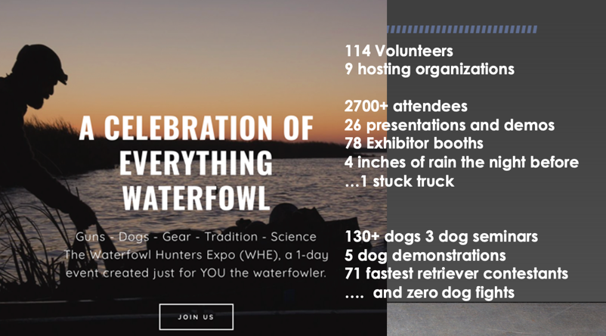
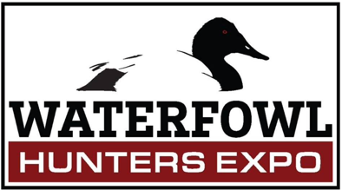
The Waterfowl Hunters EXPO. WWA led the charge to build the inaugural Waterfowl Hunters EXPO that took place on August 28th, 2021, at the Winnebago County Fairgrounds. We built a unique collaboration that included all the state’s waterfowling organizations (WWF, DU, Delta, including the DNR and UW-Stevens Point)and that was supported by professional event organizers and marketing gurus at Bast Durbin and Swift Waters (all pro bono). This EXPO was a huge success with nearly 3,000 visitors (of the two-legged and four-legged versions).

Our education efforts are attracting attention and presenting synergy opportunities. Late in 2021, the DNR told us WWA had received a $50,000 grant to bring under-represented communities into the state’s waterfowler fold. Stay tuned for how this plays out in the years ahead.
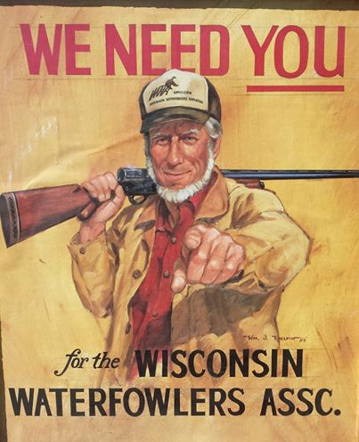
WWA ORGANIZATION: Fun, Focused, and Funded

WWA’s growing impact is premised on volunteer willingness to commit time, energy and resources to its mission. The ONLY way to grow WWA ’s impact currently is to grow volunteer willingness to play a role in that effort. And despite one chapter going inactive, 2021’s volunteers delivered in a big way.
Valley Committee:
A “model” chapter

With Brad Miller’s leadership, the Valley chapter had fun year-round doing just about everything that WWA can offer a volunteer: wood duck box hanging, sporting clays shoots, banquet fundraising and more. This team sets an example of what a fun, focused, and funded WWA chapter should be. Brad’s leadership example and extra support of state level staff as “management consultant” earned him a nod as WWA’s Volunteer of the Year. 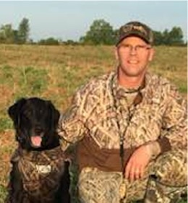

Grassroots fundraising.
Every single chapter achieved super goal status—meaning their event fundraising exceeded expectations in a significant way. Despite the largest amount ever raised by the Green Bay chapter in a single event (almost $50,000!), Waukesha chapter played “small ball” by hosting several smaller events that aggregated an amazing $66K, earning “top gun” honors for the year! Raffles not associated with events were an important part of our financial success.
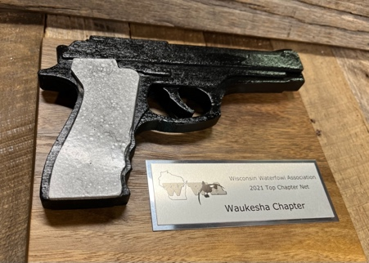
Additionally, WWA started its first “legacy gift” program and will be promoting it heavily over the coming years. While it may take a while for this program to deliver its first financial returns, when that happens, with the first such gift, we would expect it to be a high ROI program.

State Committees. Not coincidentally, this was the second year of experience with the board’s re-structured focus on WWA missions. These state-level committees formed and began developing goals in each mission or support area and began to implement strategies to achieve them. This is a significant foundation for future effectiveness.

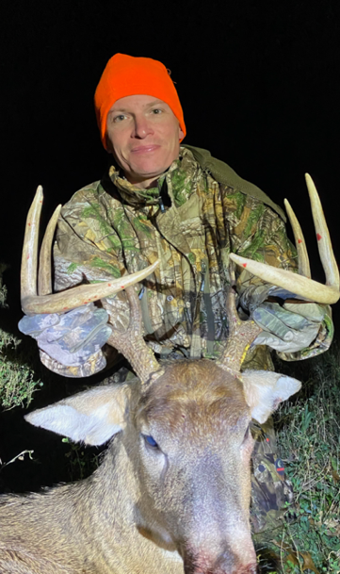
Communications.
Expanding WWA Communications

New Director George Ermert took the helm of WWA’s social media efforts as chair of WWA’s Communication / Membership Committee. He significantly increased Facebook page followers through interesting and scheduled posts (usually 5-7 per week) and regular promotions. As a professional state lobbyist, George was also key to WWA’s success in getting the duck stamp increase passed in 2021. For these and other reasons, George was named one of WWA’s two volunteers of the year.

WWA enjoyed significant visibility in the outdoors community in 2021 thanks to well-covered policy efforts, EXPO marketing initiatives, and our sandhill crane initiative. 33% of Wisconsin Outdoor News issues included WWA articles, the state’s largest newspaper featured 6 mentions, and we enjoyed several TV features. WWA also benefited from 20% social media growth.

Membership and Chapters.
The pandemic created the conditions to allow already weakened chapters to succumb –we lost 3 chapters over the past two years. WWA will be looking to better adapt our grassroots model to the current volunteer interests in 2022. Despite chapter shrinkage, membership has remained strong, with a slightly growing trend, now slightly above 7,000 members.
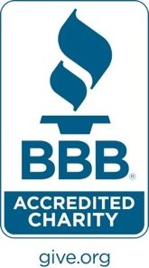
BBB Accreditation.
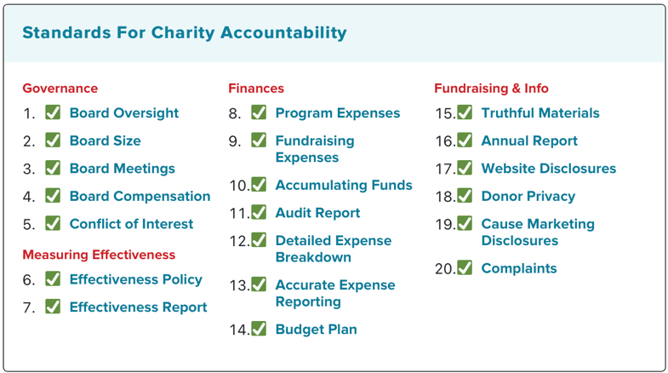
In 2021, after a thorough review of 20 categories of operations, the Better Business Bureau certified WWA as an “accredited charity” that complies with their expectations for a well-run non-profit. This accreditation should give WWA’s members, volunteers, donors, and sponsors confidence that their resources are being well-used towards the purpose of the organization.

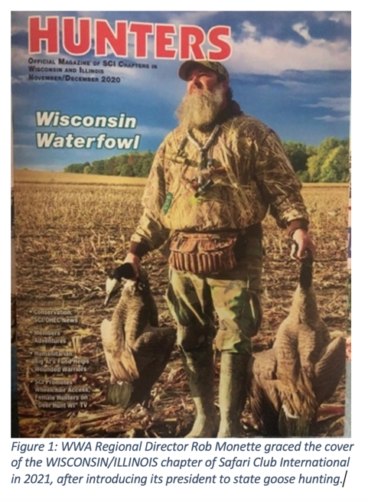
WWA Financial results
Financial Statements
WWA’s 2021 financial year can only be described in glowing terms. Chapters over-delivered in their fundraising endeavors. Two modest federal PPP loans (total: $50K) granted to sustain WWA in the height of the pandemic were forgiven. State-fundraising events, membership drives, and growing sustaining memberships, grant income, EXPO, and administration fees--all contributed to a better-than-expected bottom line: $192K of Net Income on our income statement.

This Net Income helped WWA improve its balance sheet significantly. 2021 closed with a WWA equity of $550K, up more than $200K in the year—and astounding 53% improvement!!

For the first time in a decade, these greater levels of liquidity (i.e., the balance sheet’s “unrestricted cash”) allowed the board of Directors to:
- Dedicate sufficient operating capital for 2022 ($100,000)
- Retain $70,000 for organizational reserve
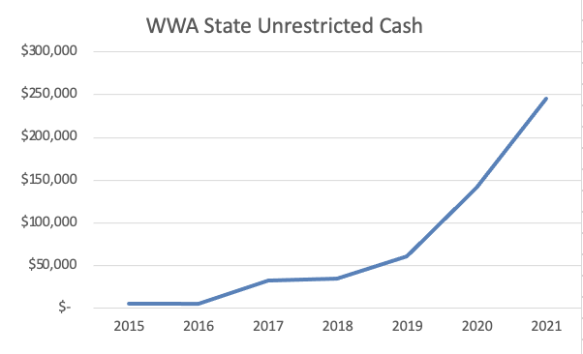
- Allocate nearly $30,000 to initiatives intended to address the risks and opportunities noted below.
<<insert pie charts after CLA comes back with compiled financial results.>>>

Risks (opportunities!) ahead:
WWA’s financial success in 2021 is cause for celebration but must be considered in the context of challenges the organization faces. WWA effectiveness in its mission areas is growing but that trend is not a guarantee. Current cash reserves are better than they have been in the past decade and WWA has begun actively diversifying revenue streams. But WWA’s small size and still-limited reserves makes it vulnerable to broad economic dynamics. Despite high staff competency and energy, it subject to catastrophic single point failure. More chapters are leveraging broad volunteer opportunities to attract and retain new members, but some chapters remain fragile. State-level committees are offering new and rewarding volunteer opportunities, but their many initiatives demand volunteer capacity and long-duration commitment of energy. Each of these risks must be addressed in the coming years to stabilize (and grow) the WWA impact seen in 2021.

<<closing – written by….???>>

