WWA Marketing Update
July 10, 2022

Social Media

Facebook Page

- We currently have 4,401 “LIKES” and 4,639 “FOLLOWERS” on our Facebook Page. This is an increase of 299 new “LIKES” so far in 2022. Based on the growth so far this year it’s likely that we will finish 2022 with 4,600 – 4,700 “LIKES”, which will be short of our 5,000 goal.

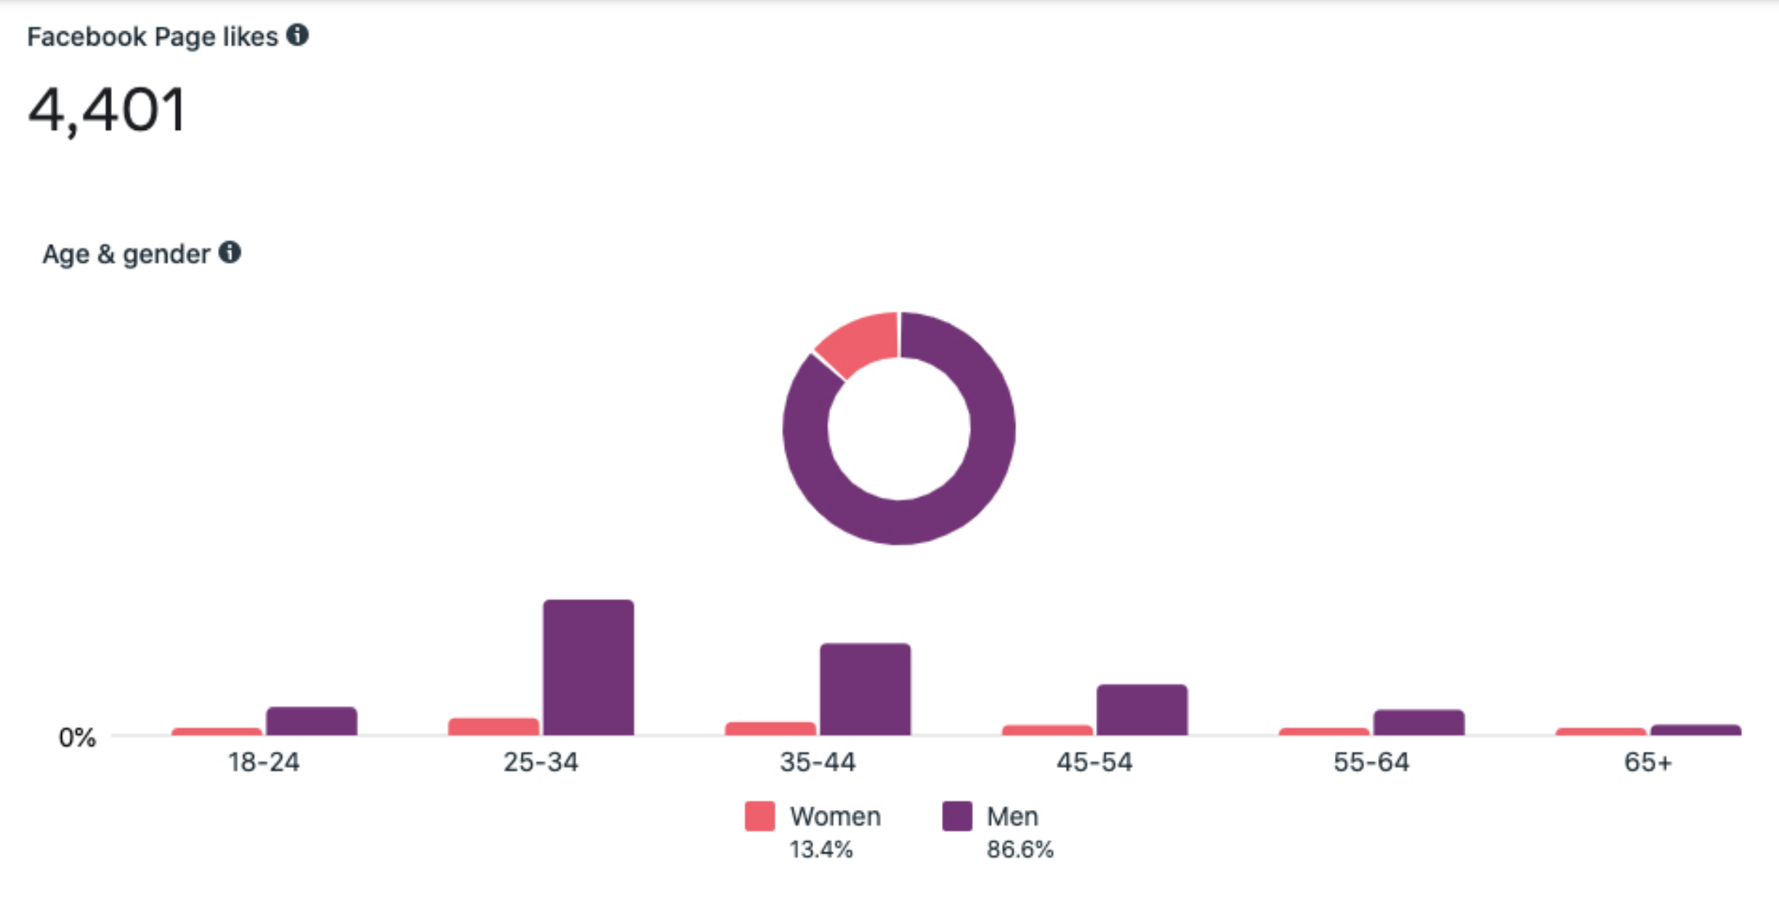

- To help draw people to our Facebook Page we have started doing giveaways with “old” WWA merchandise from the storage unit. This includes discontinued hats, knives, stickers, and other items.
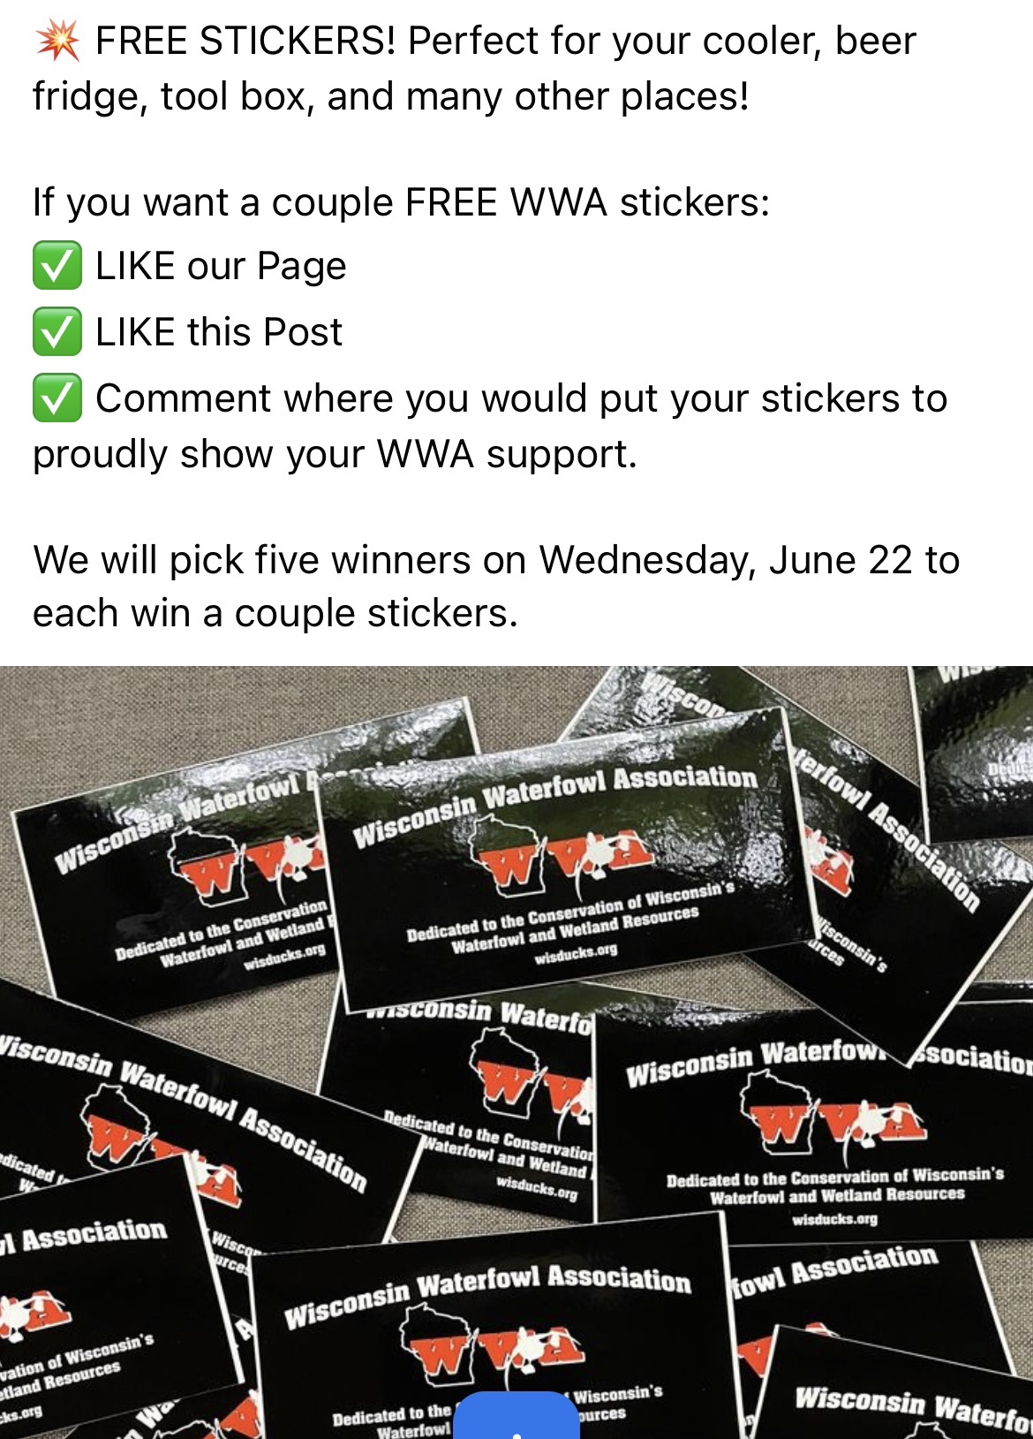
Facebook Group

- The Facebook Group now has over 5,500 members. We continue to see steady growth and involvement by members to use the Group as a forum for information sharing.

Facebook Ads

- We have begun to do Facebook ads regularly to support WWA events. These ads are geographically and demographically targeted based on the event (i.e., sporting clays in Green Bay, golf in Beaver Dam). Ad campaigns are typically $100 - $150 per event and run approximately 30 days.

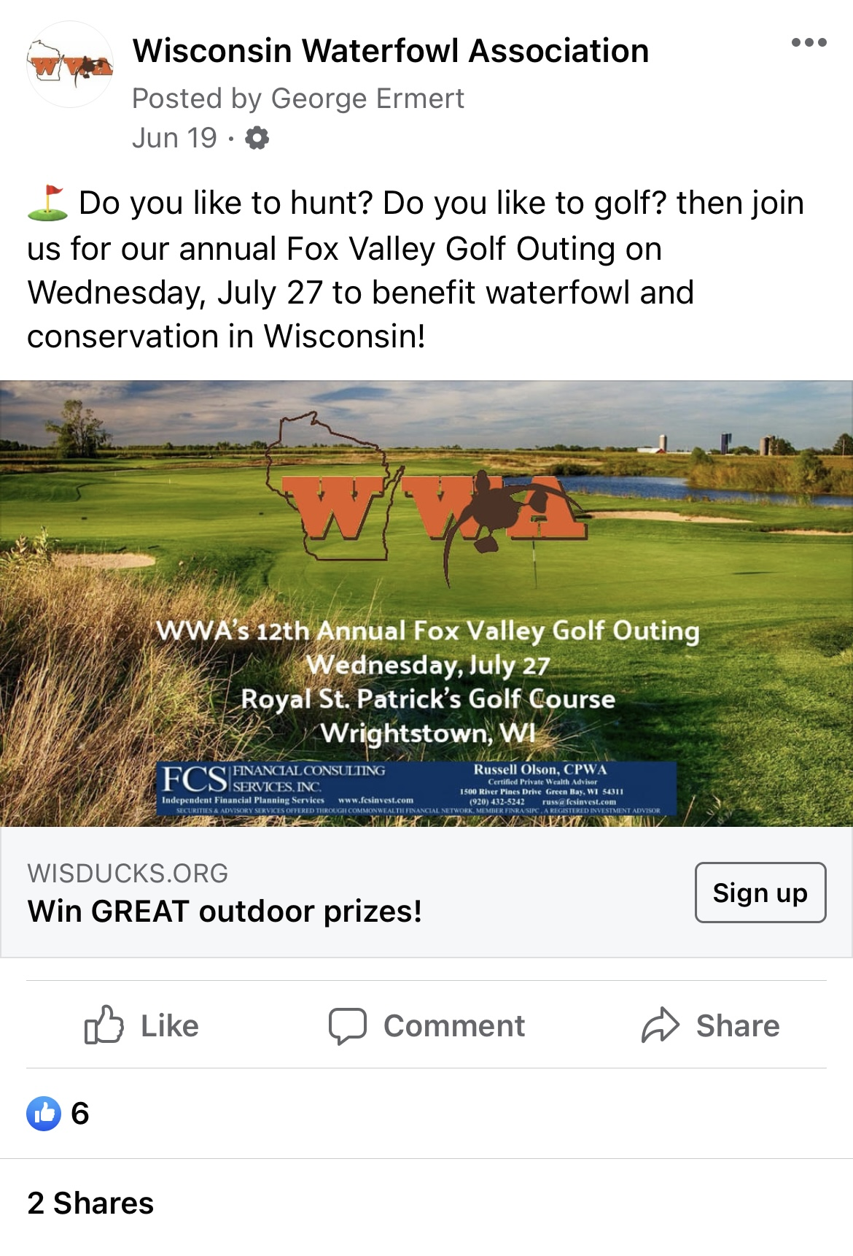

- Using a tool called a “pixel” we can track how many clicks and purchases are made from the ads. We are still working out some technical issues with the pixel to measure ROI, but to date it seems each ad has generated a positive return.

Instagram

- Our Instragram Account (@wi_waterfowl_assoc) is now integrated with our Facebook Page and we can begin to post on that platform. This is another way we can advertise our events, successes and brand to a new audience.

Summer Membership Drive

- WWA held a “Summer Membership Drive” from May 17 – June 25. The purpose was to gain membership from people who do not attend events. The campaign was supported with $250 in Facebook ads along with additional social media posts and mentions in the WWA newsletter. Anyone that signed up during this period was also eligible to win a $100 NOMAD (https://nomadoutdoor.com) gift card.

- The goal for the Drive was to gain 50 membership sign-ups. Unfortunately, we fell far short and had a total of 19 (non-life) membership sign-ups during this period. Of those 12 (or 63%) were new members of WWA. Additional details:

  - Regular Membership ($25) – 12 (7 new members)
  - Contributing Membership ($50) – 3 (2 new members)
  - Habitat Membership ($100) – 0
  - Conservation Patron Membership ($150) – 4 (2 new members)

- Total non-life membership income during the period was $1,050

- We plan to do another Membership Drive in the Fall to coincide with hunting season.

Media Outreach

- We have arranged for WWA to be featured on two Wisconsin outdoor podcasts during July and August. The focus will be the Waterfowl Hunters Expo, the upcoming waterfowl season, and WWA generally. Bruce Ross and Todd Schaller will be participating on behalf of WWA.

Nathan Woelfel Outdoors - https://nathanwoelfeloutdoors.com/

Wisconsin Sportsman Podcast - https://sportsmensnation.com/podcasters/wisconsin-sportsman

- The Marketing Committee has purchased a large novelty check that can be used to promote WWA donations. This is a dry-erase check that can be modified and used for any contribution. We recently used this check with the New Berlin Trap Club for the West Allis Chapter donation. The photo was shared with local media outlets, the Outdoor News, and on social media.

