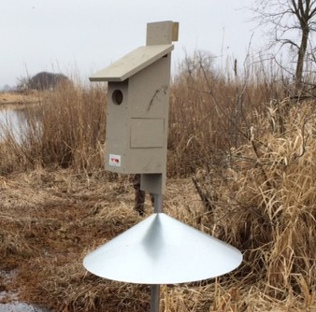
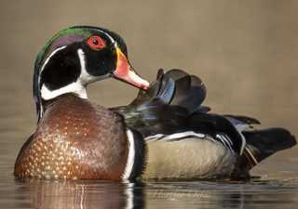
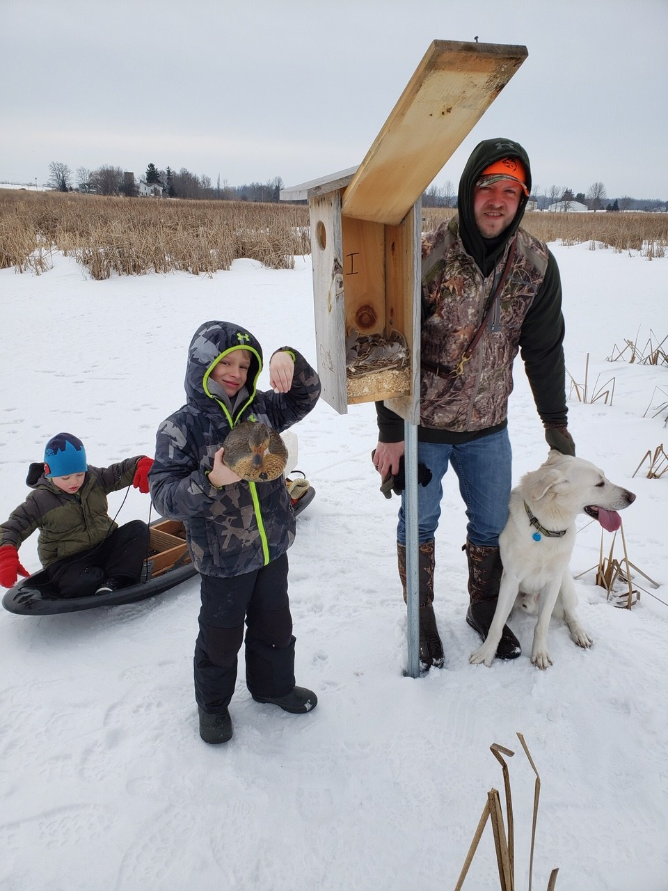

Join the WWA team -- help Wisconsin’s waterfowl populations!

WANTED
Wood Duck Box Program sponsor
For decades, WWA has managed the largest Wood Duck Box program in Wisconsin. Our volunteers have placed thousands of nesting boxes on public or private lands around the state, expanding nesting opportunity for wood ducks, hooded mergansers, and occasionally, screech owls!
This program works! It has helped place more ducks on the landscape, year after year, for Wisconsin hunters.
We want to expand this program in the coming years, but…

We need your help!

WWA is hoping to find one or several key individuals to sponsor our highly successful wood duck box program. We are hoping to raise $4500 to purchase enough lumber to fund the program for the next three to four years. Sponsors will receive tax benefits and recognition, while taking comfort in growing state duck populations.

Sponsors will receive:
- Special recognition in our newsletter (distributed to 14,000+),
- A semi-annual WWA update from our executive director,
- Embroidered WWA camo shirts and
- A custom made Bruce Urben hand-carved decoy!
________________________________________________________________________________________________________________________
CONTACT
B.J. Grassmann, WWA Habitat Committeee Chair -- grassmannbj@gmail.com -- (920) 428-6543‬‬‬‬‬‬‬

Wisconsin Waterfowl Association • p.o. bOX 427 • WALES, WI • 53183-0427
Phone/FAX: 262-968-1722 • www.wisducks.org • habitat@wisducks.org

