WWA Marketing Update
October 16, 2022

Here is an update on the activities of the Marketing Committee since our last WWA Board Meeting in July.

Earned Media

- The Marketing Committee was able to help with promotion of WWA and the Waterfowl Hunters Expo with some interviews on local, Wisconsin-focused outdoor podcasts. This included:
  - August 9, 2022 - “2022 Wisconsin Waterfowl Hunting Forecast and the Wisconsin Waterfowl Hunters Expo” Wisconsin Sportsman Podcast. Listen to the podcast: https://bit.ly/3P5reSx

  - August 10, 2022 – “Nathan Woelfel Outdoors Podcast: Episode 33” Listen to the podcast: https://bit.ly/3bJBn9F

- Following the construction of the disabled-accessible blind at the Jackson Marsh State Wildlife Area, the Marketing Committee helped draft and distribute a press release to local media outlets. This included Washington and Ozaukee County newspapers, and outdoor writers / publications (press release attached). Below is one of the news stories on the new blind. We anticipate seeing more stories as the papers come closer to publication date.

  - “Seeing multiple uses for new hunting blind. Wisconsin Waterfowl Association reveals new concealment in Jackson Marsh Wildlife Area” Washington County Daily News, October 14, 2022. https://www.gmtoday.com/daily_news/news/seeing-multiple-uses-for-new-hunting-blind/article_afba48ec-4bb7-11ed-bedc-afae38a6df35.html

Social Media

- The Marketing Committee spent many hours at the Waterfowl Hunters Expo doing interviews with WWA sponsors and other notable vendors / attendees to draw attention to the event and give some promotion to these companies / products. Interviews included:
  - Sherper’s
  - Buck Garner
  - Vortex
  - Wisconsin DNR
  - Lucky Duck
  - The Finisher

- Facebook
  - Updates to the social media site have now gotten rid of “Page Likes” and the platform now focus solely on “Followers”. We currently have 4.9k Followers and should reach over 5k by the end of the year.

  - Online ads
    - We are currently running online ads for the 2022 Membership Calendar on Facebook. As of 10/16/2022 we have had 55 purchases from the ad resulting in approximately $2,000 in sales (according to our Facebook Pixel). To date, we have spent approximately $250 on ads (with a planned budget of $500).

- Instagram
  - Our Instagram account up and running and growing slowly. We currently have only 186 followers on that platform, but we are exploring ways to grow that platform more quickly.

Membership

- We are still planning to do a Fall Membership Drive. However, due shortages in membership gifts the start of that campaign has been pushed to early November to ensure we have those items in hand.
  - We will use Facebook ads, along with targeted emails to individuals who previously were WWA members but have not renewed.
  - The goal of the campaign will be 50 memberships.

Advertising / Other

- Toe Tags
  - The Marketing Committee has purchased 2,000 WWA-branded Toe Tags. These are both an educational item as well as way to promote WWA.
  - We are doing social media posts to educate hunters on the tagging requirements at the state / federal level and encouraging people to ensure that they follow them when out hunting.
  - We will be giving away the Toe Tags on social media and at upcoming events.
  - Total cost of the tags was $300.00 (usual cost is $600 – we purchased them on a super sale event).
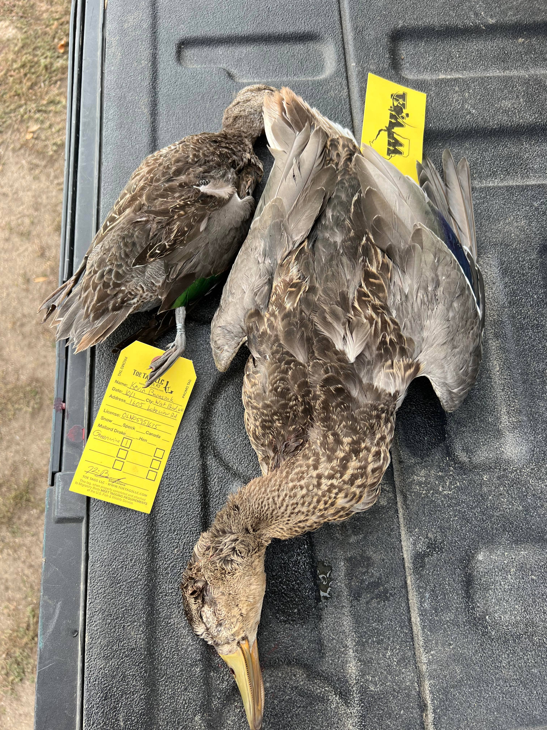

- The Marketing Committee will meet again on Wednesday, October 26 to discuss plans for the rest of 2022 and set goals for 2023.

In addition to the above notable activities, we are happy to report that WWA has gained a new volunteer / Marketing Committee member! Nathan Woelfel (from the above-mentioned podcast “Nathan Woelfel Outdoors”) does marketing / social media in his day-job and has volunteered to help us with our efforts.

