There are two contracts for Board consideration, looking for approval. This

- Public Lands Wetland Restoration Specialist contract with DNR
- EXPO Vendor management with Bast Durbin Associates

Public Lands Wetland Restoration Specialist contract with DNR
Summary: As discussed for months, we are now in a position to enter a contract with the DNR to as a sole-sourced provider of wetland restoration services on state-managed land. This is a remarkable opportunity to expand our habitat mission impact, while being subsidized by the state (and P-R dollars) up to 3 dollars for every 1 dollar of WWA “funds”. Total value of the service we’d provide is estimated to be $76,000 (maximum). WWA would be responsible for providing $19,000 (maximum) annually in all forms of support (Insurance, Admin, Management hours, operational support, overhead etc. as well as actual funding for the position). The EXPO will be sponsoring $6,000 to help WWA offset that $19,000 (maximum). We would charge the DNR the remaining $56,000 per year to pay for the position. These numbers are all maximum amounts under the contract. More likely (budgeted) amounts are shown in table below.

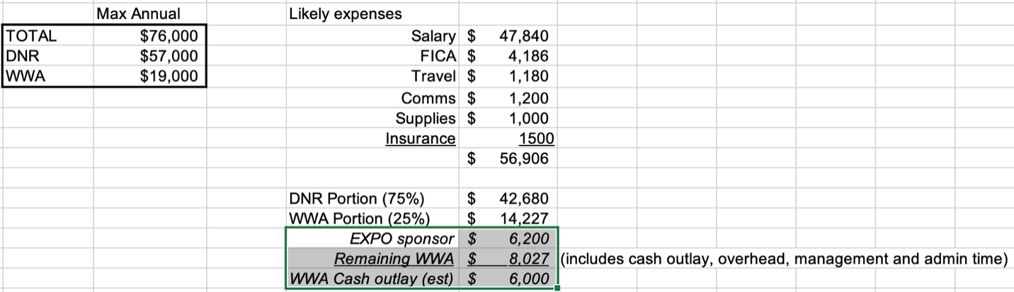

Based on current estimates, the annual cost for this position, to WWA (exclusive of DNR and EXPO) will be in the neighborhood of $6-7,000. While some of these costs are likely to be front-loaded (Feb through April) as we identify and down-select candidates, then on-board and outfit them to fulfill the duties, overall, this program represents a unique value to WWA and its membership. It will appeal to members and donors, provide marketing opportunities, and improve waterfowl habitat around the state that would be open (mostly) to public land duck hunters. If this program is successful, we can replicate it around the state.

The costs and revenues associated with this program is already included in WWA budget draft 1 under Restoration Revenue (Income) and Program Services Wages, Travel, and Other. As an added benefit, this will further improve WWA’s financial ratios so important to our BBB accredited rating.

EXPO Vendor management with Bast Durbin Associates (BDA)
Note: The EXPO Steering Committee has already approved this expenditure, but since the contract is with WWA, the WWA Board of Directors must approve the signing of this contract by the Executive Director who is also the EXPO Chairman.

Background: An explicit sustainment EXPO goal is to “incrementally outsource critical functions” of the EXPO. This goal, to supplement volunteer effort with professional effort, is important to the long-term health of the EXPO in the face of the volunteer effort needed to run the event. Last year, and again this year, we outsourced marketing to Swift Waters to the tune of $500 per month.

This year, the EXPO Steering Committee has decided to outsource the vendor management function (billing, placement, communications, invoicing, etc.) at an overall cost of $12,000 to Bast Durbin Associates. While expensive, it enhances an important part of the EXPO (exhibitors) and substantially reduces the associated volunteer workload. There are some front-loaded costs to this effort that will allow reduced per vendor costs in the future, but we do not expect costs to actually go down in future EXPOs. There is also a required software subscription component $39/month but the lion’s share of the expense is in staffing to support the software use in managing EXPO exhibitors.

The EXPO will slightly increase exhibitor pricing to cover some of the costs of implementing this professionalization, and maybe attract more exhibitors, but not enough to eliminate some impact on the EXPO’s bottom line. Even so, the forecast EXPO financial budget does not envision going negative, and with a current $35,000 balance in the EXPO account, this decision does not risk any cash impact on WWA. The costs of this initiative is included in the WWA budget draft 1, in the EXPO revenue and expense lines, but for greater detail, consider the EXPO3 budget details below.

