WWA Marketing Update

2022 Marketing Recap

Social Media
WWA’s Social Media presence continues to grow and effectively reach our targeted audiences to spread our mission.

  - Facebook Page: We currently have 5,019 Facebook Followers. In 2022, we gained 613 new Followers (14% increase). While our following in social media is not yet huge, our engagement rate (the actions that someone takes on our Page or posts – Likes, comments, etc.) continues to be well-above the industry average. Our engagement rate in 2022 was 8.25% - the industry average is 0.5% - 0.99%. As the Page following grows, the harder it will be to keep the engagement rate high.

  - Instagram: We created the WWA Instagram account in July 2022. We currently have 214 Followers.

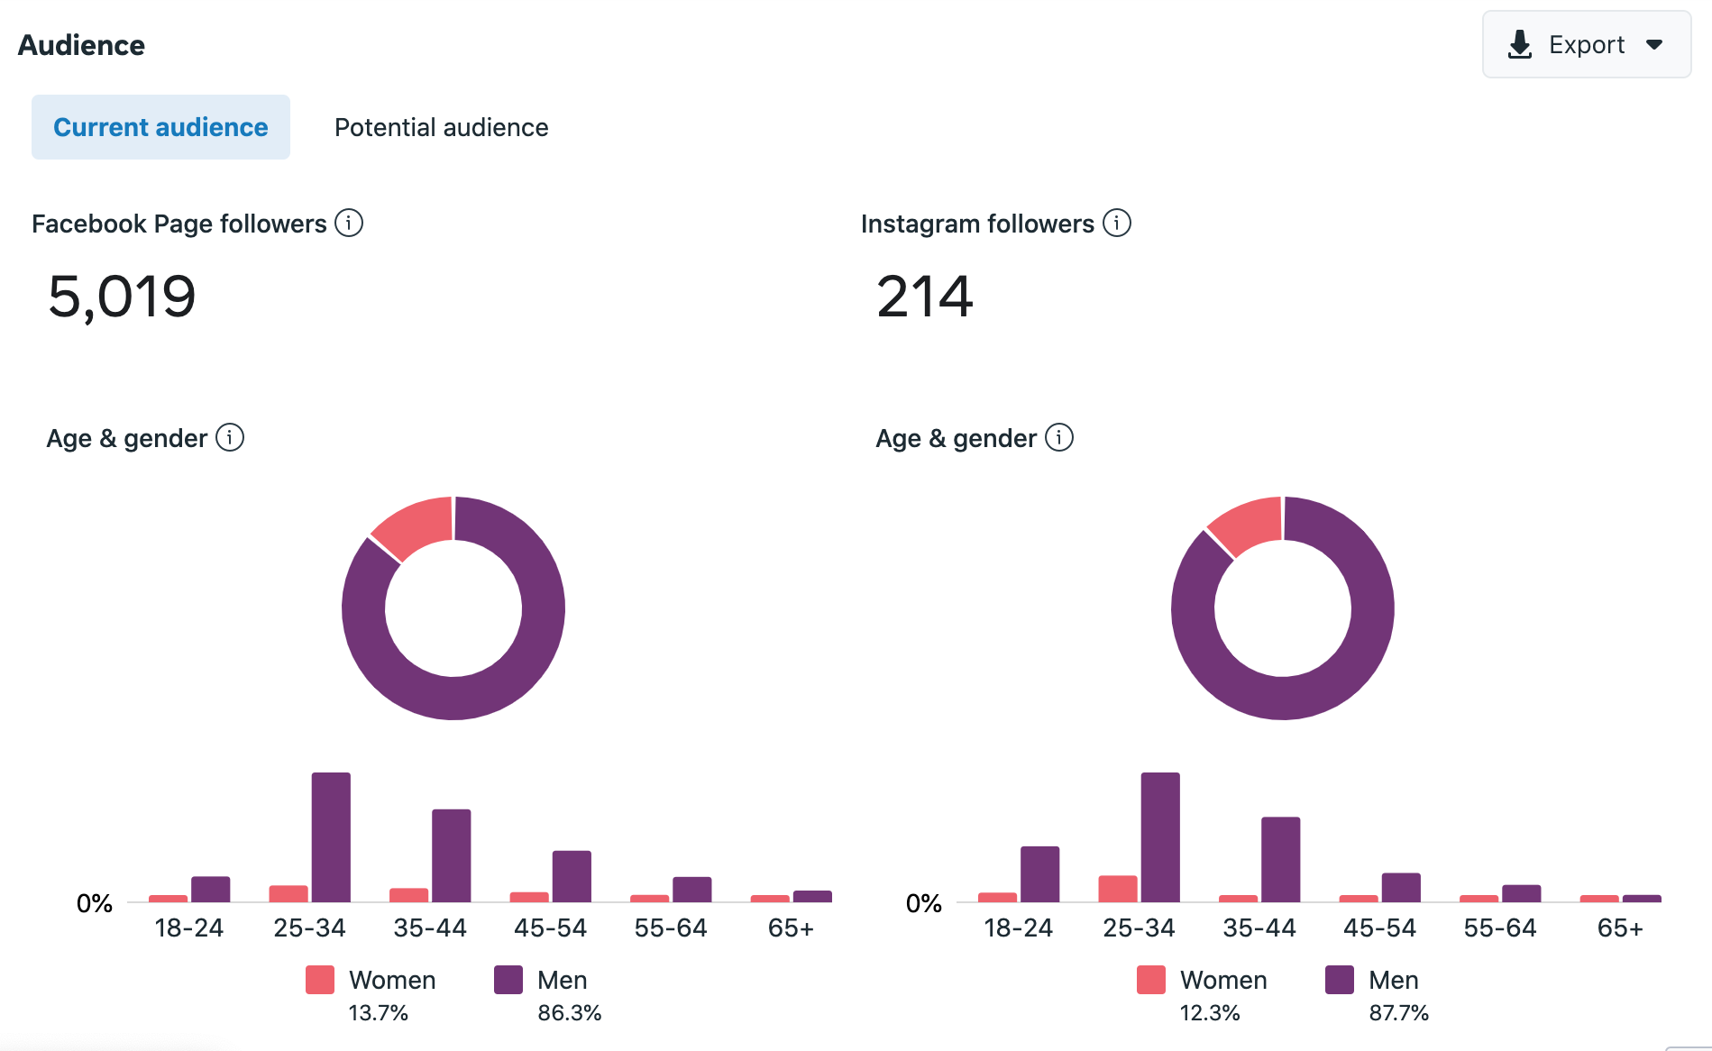

- Facebook Group: The Facebook Group saw significant growth in 2022. The Group currently has 6,868 total members – an increase of 1,650 members. We continue to see steady growth and involvement by members to use the Group as a forum for information sharing.

Facebook Ads
WWA continues to utilize paid advertising on Facebook to publicize chapter events and other key initiatives of the organization.

Most recently, WWA used Facebook ads to promote two key initiatives – 2023 Calendar Sales and a Fall Membership Drive.
- 2023 Calendar Sales: We ran targeted ads from September 15 – December 15, 2022, at a cost of $508.61. This resulted in 145 purchases from the ad. The conversion value of those purchases was $5,905.00

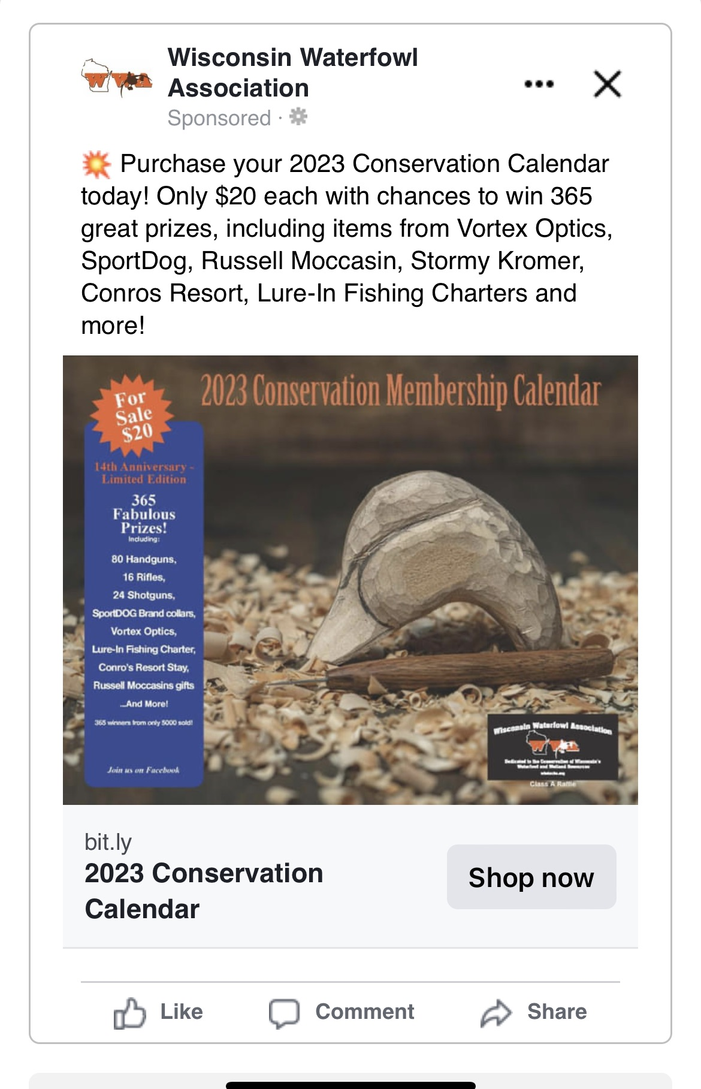

Membership Drives
One of the goals of the Marketing Committee is to increase the number of individuals who become members of WWA outside of events / calendar sales. The number of individuals who actively join WWA outside of events on an annual basis is very low, so there is a lot of opportunity to grow that number to provide additional regular revenue to the organization.

To achieve the goal of growing membership, the Marketing Committee did several “Membership Drives” during 2022 to get former members to rejoin the organization and new people to become members. These initiatives were supported with targeted Facebook ads as well as targeted emails to former members and individuals who attended the Waterfowl Hunters Expo.

- 2022 Fall Membership Drive: Our most recent Membership Drive ran from November 15 – December 17. We spent $78.10 on targeted Facebook Ads and sent targeted emails to former WWA members and attendees of the Waterfowl Hunters Expo. These efforts resulted in 26 membership sign-ups during that time equaling $1,400
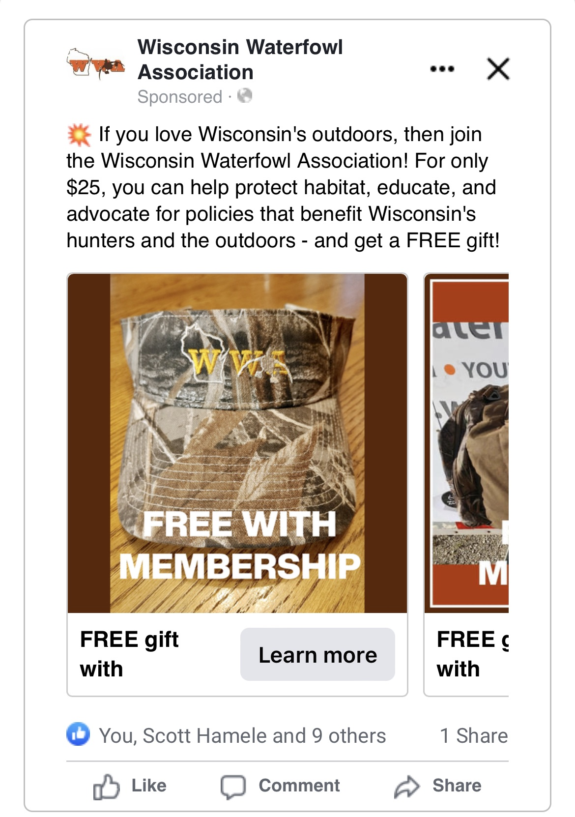

2023 Marketing Committee Goals

- Update / Revise the WWA Website. In many instances, the WWA website is a potential member or potential donor’s first impression of our organization. While our current website functionally works, it is extremely hard to navigate and contains a lot of outdated and unneeded information. More importantly, the website looks outdated and falls significantly short of many other conservation organizations’ online presence (i.e., Wisconsin Wildlife Federation).

The Marketing Committee would like WWA to invest in redoing the website in 2023. This would require WWA to solicit bids from potential website vendors, as well as significant time from staff and volunteers to help map the new website and draft copy. Marketing Committee members George Ermert and Nathan Woelfel have already agreed to help lead the site mapping and content development of a new website.

(Cost = approx. $10,000 and staff / volunteer time)

- Increase WWA Earned Media. WWA is doing many great things for conservation and sportsmen in Wisconsin – but we don’t do enough to publicize those things. One way we can do a better job telling our story is to do more earned media with news outlets in Wisconsin.

In 2023, our earned media efforts will include outreach to different media outlets to publicize initiatives like the Public Lands Ecologist and the Waterfowl Hunters Expo.

(Cost = staff / volunteer time)

- Increase WWA Membership / Canine Life Memberships. We will continue to promote a Spring and Fall Membership Drive in 2023 with a goal of gaining 100 membership sign-ups outside of events. In addition, we will also introduce a new marketing push to gain more Canine Life Memberships in 2023.

(Cost = $750 for Facebook ads, staff / volunteer time)

- Increase WWA Visibility through Paid Marketing. Our current membership of 7,000 people only represents about 7.7% of all waterfowl hunters in Wisconsin. We need to do more to increase our visibility to our target audience and potential donors. We will investigate potential paid marketing opportunities for WWA to reach our target audience. This may include print advertising, radio advertising, podcast sponsorships, event sponsorships, new merchandise, and more.

(Budget = $2,500)

