- Budget Narrative

WWA proposes to absorb a substantial percentage of NRCS monitoring effort, freeing up NRCS biologists to implement or expand new programs. Without supplemental experienced technical and supervisory capacity, NRCS will be stretched to successfully implement emerging or prioritized programs. Simultaneously, this initiative will build a local partner’s (i.e., WWA’s) restoration technical competency and capacity.

Properties with NRCS easements or agreements would be in locations that WWA ecologists could efficiently monitor. Under this outsourcing effort, WWA would monitor easement/agreement compliance. Additionally, WWA’s site visits would provide vegetation and infrastructure assessments together with management plans and estimated costs.

A single additional ecologist hired under this proposal would bring WWA team strength to a total 4 ecologists. Monitoring duties would be spread out over all four ecologists, who would also conduct WWA’s other habitat restoration missions on private and public lands.

The budget in this proposal is based on providing 1.0 FTE of ecologist effort per year for three years with the attendant WWA support. Inflation is incorporated at 3.5% per year. This offering could be expanded in scope, duration, or depth, as described at the end of this Budget Narrative.

Personnel Costs
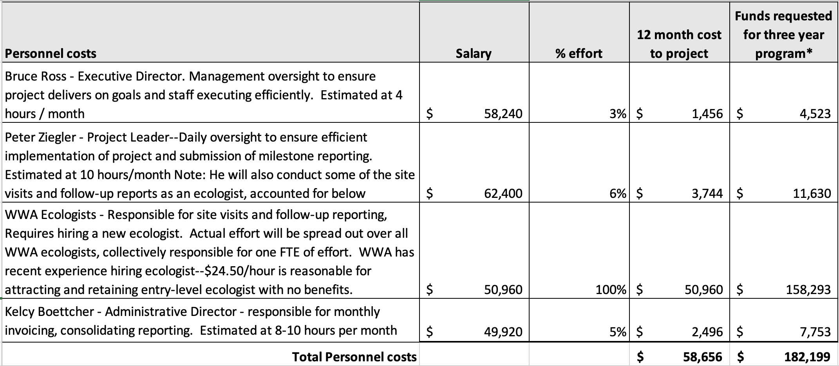
Notes:
- Personnel costs include 7.5 % employer SS and state unemployment insurance.
- Each of WWA’s four ecologists (three currently in place, plus a new hire) will absorb a percentage of the monitoring responsibilities of this proposal. This will have some travel efficiencies but will require more supervisory effort by the project manager.

Fringe Benefits
Three weeks PTO for one new ecologist. No other fringe benefits are anticipated under this proposal. 3 weeks PTO at $24.50 per hour = $4,425, or a total of $13,744 for three years.

Travel Costs
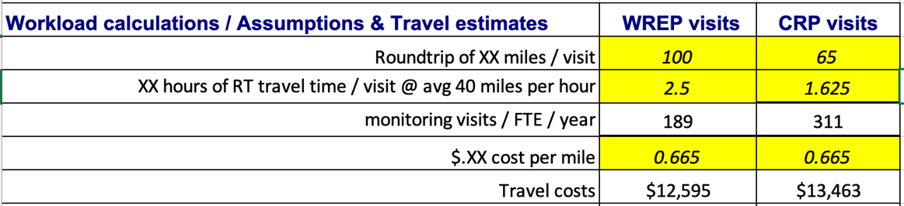
Travel costs are estimated from the workload calculations below, at today’s federal reimbursement rate of $0.665 per mile. Different milage assumptions were used for the different types of site visits anticipated under this proposal. Based on the below calculations, WWA estimated $13,500 for year one of travel costs, inflated in subsequent years at 3.5% for a total of $43,487. Note that travel will be associated with some combination of both WRP visits and CRP site visits.

Equipment
No equipment costs.

Supplies
Include the following one-time costs:
- Work provided computer – laptop at $1000
- WWA-provided phone - $500

Contractual
No contractual expenses are anticipated.

Construction
No construction expenses are anticipated.

Other direct charges
- Insurance (General Liability insurance increment, and worker’s compensation) is expected to be $1000 per year.
- Internet service - $50 / month for ecologist’s home office plus
- MS Office suite at $100 / year annual subscription .
- Phone service - $75 / month

Indirect charges
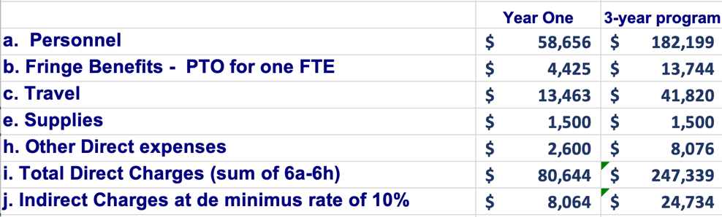
WWA will charge a de minimus indirect cost rate of 10% totaling $24,734 for the three-year program.

TOTAL PROGRAM COSTS
Fully allocated cost for year one for this easement monitoring service is $88,708. Total NRCS investment for the three-year program would be $272,072. This equates to a significantly expanded monitoring and reporting effort, at a fully-loaded cost per visit of:
- Less than $500 per wetland easement.
- Less than $300 per CRP site visit.

PROGRAM EXPANSION POSSIBILITY
- This program’s capacity can be expanded in increments of one FTE for an $93,000 / FTE.
- This program duration can be expanded years four and five, for $95,000 $98,000, respectively.
- This program activities can be expanded to have WWA implement management and infrastructure repair effort, pricing to be agreed between NRCS and WWA.

