- Concept, Partner, Design, Goals and Objectives

Concept: The Wisconsin Waterfowl Association (WWA) is pleased to present a low-risk, low-cost, high reward proposal to expand NRCS wetland reserve easement program (WREP) and conservation reserve program (CRP) monitoring capacity. WWA proposes to absorb a substantial percentage of NRCS monitoring effort, freeing up NRCS biologists to implement or expand new programs. Without supplemental experienced technical and supervisory capacity, NRCS will be stretched to successfully implement emerging or prioritized programs. Simultaneously, this initiative will build a local partner’s (i.e., WWA’s) restoration technical competency and capacity.

Properties with NRCS easements or agreements would be in locations that WWA ecologists could efficiently monitor--focused in central and eastern Wisconsin, including the Glacial Habitat Restoration Area (GHRA). Under this outsourcing effort, WWA would monitor easement/agreement compliance. Additionally, WWA’s site visits would provide vegetation and infrastructure assessments together with management plans and estimated costs.

At the individual property level, this effort would improve collaborative management between landowner and NRCS. At the state management level, the aggregated results would provide greater confidence that the resources required to realize the full benefit of these programs are adequate—or not.

Providing this service efficiently would require hiring an additional ecologist. But this proposal is easily scalable in breadth, depth and duration in increments of one FTE. If desired, WWA can:
- Provide broader geographic coverage.
- Coordinate the property management actions uncovered by site visits.
- Expand the duration from three years to the NFO’s maximum of 5 years.
Current WWA supervisory and administration capacity would allow hiring of up to three new ecologists to support this program.

A single additional ecologist would bring WWA team strength to a total 4 ecologists. Monitoring duties would be spread out over all four ecologists, who would also conduct WWA’s other habitat restoration missions on private and public lands. Adding this additional technical capacity to both NRCS and WWA is at the heart of the NFO’s purpose. This will yield improved water quality for Wisconsinites and enhanced habitat for local wildlife, including species of concern.

WWA Background: The 501(c)3 Wisconsin Waterfowl Association was incorporated in 1983 and has grown to a membership of >7,000 state-wide. WWA focuses its efforts in three mission areas:
- Restoring and conserving Wisconsin’s waterfowl and wetland resources,
- Educating state waterfowlers as they progress from natural resource consumer to steward; and
- Promoting policies that protect Wisconsin’s wetland resources.
WWA has an executive director, operational and administrative staff that are guided in the execution of these missions by a volunteer board of directors. Each are adequate to absorb the duties proposed under this NFO response. Staff—including ecologists--operate out of their home offices, located generally in central and eastern Wisconsin.

WWA’s habitat restoration mission is a 30+ year core competency. WWA has conducted over 400 projects, and >10,000 acres of restorations in the past three decades. The habitat mission can be divided into two broad categories:
- WWA’s Private wetland restoration program: WWA’s habitat restoration efforts have historically targeted privately-held wetlands. WWA has historically assigned 1 FTE of ecologist effort to this program.
- WWA’s State-managed wetland restoration program: Since January 2023, WWA has partnered with the Wisconsin Department of Natural Resources (DNR) to expand our restoration focus to state-managed properties, initially in the eastern half of the state. To support this partnership, WWA hired two ecologists and is currently providing 1.5 FTE of effort to this partnership with the DNR, under an agreement that requires only 1.0 FTE of ecologist effort. This surplus capacity of experienced habitat restoration ecologists allows WWA to offer this program with confidence of a rapid and successful launch.
The appendix to this narrative has the resumes of the WWA Habitat Team which display the needed experience to execute this proposed program efficiently.
Program Design: WWA and NRCS will define the specific easements/agreement for which WWA will take over monitoring responsibilities, primarily in central and eastern Wisconsin, that can be undertaken by one FTE.

The GHRA region is particularly important to WWA as those uplands provide important breeding habitat to support the Upper Mississippi Joint Ventures habitat management goals. Bonus: WWA and its conservation partners are planning an outreach event in the GHRA area to promote landowner signup to CRP. We anticipate doing a second event promote additional habitat projects these events will yield greater NRCS connectivity and additional programmatic leads.

WWA and NRCS will further agree on the compliance, vegetation and infrastructure standards to be considered in property assessment, using NRCS technical standards as appropriate. WWA will assign ecologists to monitor those sites and develop assessments to achieve the objectives noted below. While at each property site, ecologists will assess the quality of vegetation and visible infrastructure conditions, if any.

Vegetation focus will be on quantifying / describing stands of pioneer populations of invasives species. Infrastructure reviews will focus on equipment/conditions necessary to achieve the goals of the property, such as water control structure functionality, culvert adequacy, and berm conditions. WWA will provide each monitoring report to the NRCS technical representative and include a control or repair plan with estimated costs as appropriate.

Consistent and complete data capture will be consolidated in an NRCS data set that can be easily incorporated into an NRCS database. This accumulated information will facilitate NRCS’ comprehensive cost estimation and management of the functional challenges facing WREP easements in Wisconsin.

If NRCS funding for vegetation management or infrastructure maintenance becomes available, WWA could, if mutually acceptable, expand this agreement to include solicitation of bids and hiring of contractors. These optional actions are consistent with ecologists’ other duties. That service is not included in the effort/cost estimates for this NFO.

This proposal’s 1.0 FTE of ecologist effort is estimated to be sufficient to review either 320 CRP properties OR 200 wetland reserve easements annually, or more likely, some combination thereof as desired by NRCS.

While this capacity would be achieved through WWA’s hiring of a restoration ecologist, the actual monitoring effort will be split among WWA’s entire habitat team of 4 ecologists to meet the 1.0 FTE expectation.

In addition to NRCS providing easement/agreement monitoring services, those four ecologists will have responsibilities to deliver WWA’s full range of wetland restoration services on other private and state-managed properties. Building a wetlands-focused cohort of four ecologists steeped in all facets of wetland restoration and maintenance is a key component of how this proposal supports the NFO’s partner capacity building goals. This bench strength will help WWA’s habitat program expand the geographic range of all WWA wetlands-focused habitat programs.

By the numbers--Program Objectives, over three years. Organized by the NFO Purposes
- Build technical capacity to implement NRCS programs:
- Up to 580. The number of easements monitored and assessed OR 960 CRP sites evaluated. More realistically, a balance between the two types of site visits.
- >1 FTE NRCS biologist freed from routine site visits to WREP or CRP sites. This will allow them to focus their attention on expanding, high priority NRCS programs.
- Build technical and ecologist capacity of an NRCS local partner, i.e., WWA.
- Four. Expansion of WWA’s Habitat team from three to four ecologists will serve both the easement monitoring program for NRCS and contribute additional capacity to WWA’s other habitat restoration programs.
- Twelve new WREP/CRP leads. A useful synergy of this partnership: Each WWA ecologist will be attuned to NRCS programs and services--WWA will generate more leads for those programs, estimated to be 4 annually, for a total of 12 over the three-year program.
- Achieve positive and measurable natural resource conservation outcomes for the state.
- Between 195 and 321 = The number of vegetation and/or infrastructure assessments of on NRCS affiliated properties (depends on the sites NRCS assigns to WWA.
- WWA’s additional ecologist capacity will allow expansion of its public and private wetland restoration programs. It’s reasonable to expect at least:
  - 3 additional private-lands wetland restorations, est at 40 acres restored.
  - 2 additional state-managed wetland restorations, est at 50 acres restored.

- Budget Narrative

The budget in this proposal is based on providing 1.0 FTE of ecologist effort per year for three years with the attendant WWA support. Inflation is incorporated at 3.5% per year.

Personnel Costs
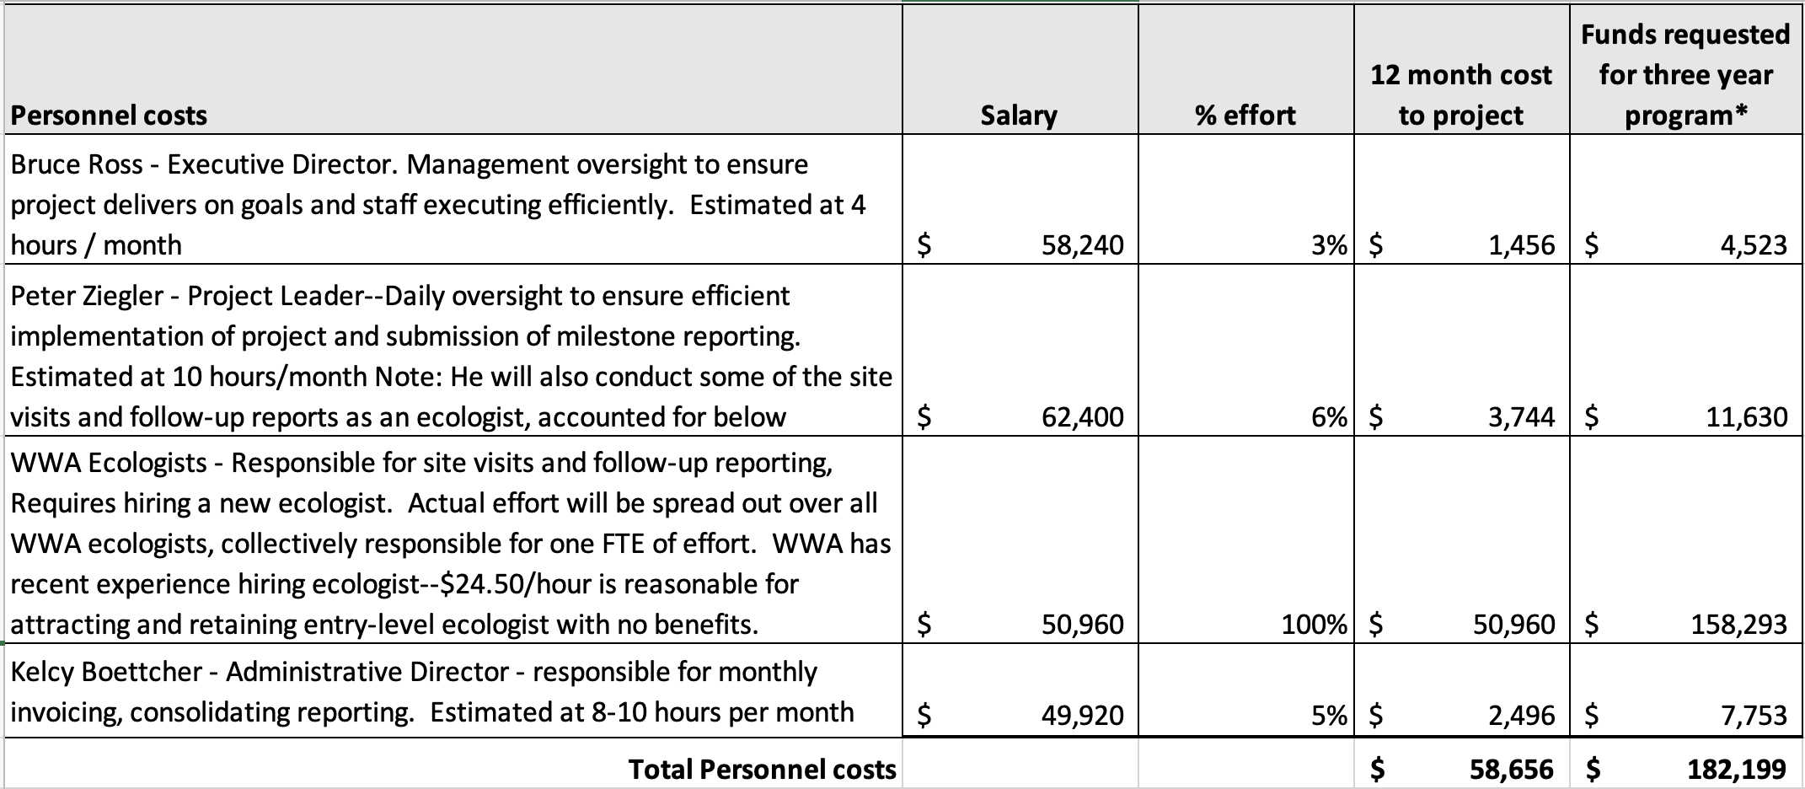
Notes:
- Personnel costs include 7.5 % employer SS and state unemployment insurance.
- Each of WWA’s four ecologists (three currently in place, plus a new hire) will absorb a percentage of the monitoring responsibilities of this proposal. This will have some travel efficiencies but will require more supervisory effort by the project manager.

Fringe Benefits
Three weeks PTO for one new ecologist. No other fringe benefits are anticipated under this proposal. 3 weeks PTO at $24.50 per hour = $4,425, or a total of $13,744 for three years.

Travel Costs
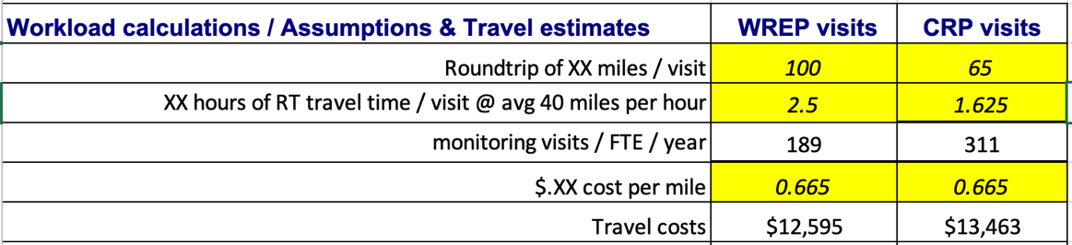
Travel costs are estimated from the workload calculations below, at today’s federal reimbursement rate of $0.665 per mile. Different milage assumptions were used for the different types of site visits anticipated under this proposal. Based on the below calculations, WWA estimated $13,500 for year one of travel costs, inflated in subsequent years at 3.5% for a total of $43,487. Note that travel will be associated with some combination of both WRP visits and CRP site visits.

Equipment
No equipment costs.

Supplies
Include the following one-time costs:
- Work provided computer – laptop at $1000
- WWA-provided phone - $500

Contractual
No contractual expenses are anticipated.

Construction
No construction expenses are anticipated.

Other direct charges
- Insurance (General Liability insurance increment, and worker’s compensation) is expected to be $1000 per year.
- Internet service - $50 / month for ecologist’s home office plus
- MS Office suite at $100 / year annual subscription .
- Phone service - $75 / month

Indirect charges
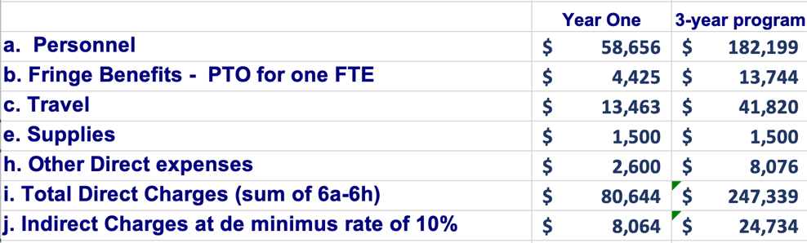
WWA will charge a de minimus indirect cost rate of 10% totaling $24,734 for the three-year program.

TOTAL PROGRAM COSTS
Fully allocated cost for year one for this easement monitoring service is $88,708. Total NRCS investment for the three-year program would be $272,072. This equates to a significantly expanded monitoring and reporting effort, at a fully-loaded cost per visit of:
- Less than $500 per wetland easement.
- Less than $300 per CRP site visit.

PROGRAM EXPANSION POSSIBILITY
- This program’s capacity can be expanded in increments of one FTE for an $93,000 / FTE.
- This program duration can be expanded years four and five, for $95,000 $98,000, respectively.
- This program activites can be expanded to have WWA implement management and infrastructure repair effort, pricing to be agreed between NRCS and WWA.

- Expected Accomplishments and Deliverables (<3 pages)

Estimating outputs at one FTE.
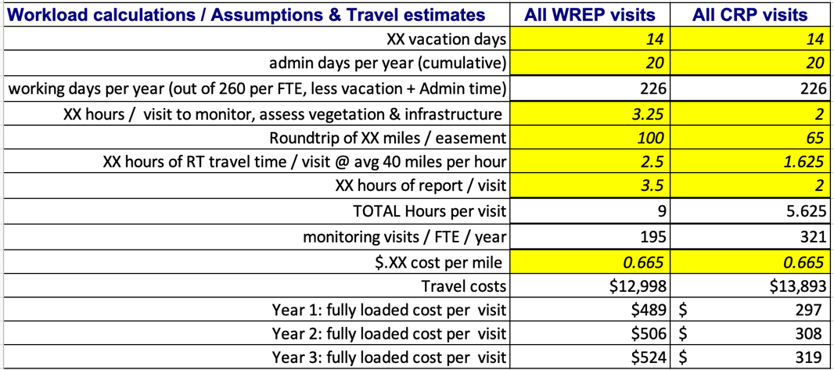
To provide a sense of the activities and output that one FTE would provide in WREP easement or CRP monitoring, WWA estimated how much effort per visit would be required to determine how many WREP easements or CRP properties could be monitored by one FTE in a year. The three key factors in effort per visit are: travel time, duration of visit, and administrative follow-up after each visit, estimated above, highlighted in yellow. The possible variances can be considerable, making each these assumptions a risk area absorbed by WWA.

Since there are different levels of effort required for a typical CRP monitoring versus a typical WREP easement monitoring, WWA calculated the effort required for each (9 hours and 5.6 hours, respectively). So theoretically, one FTE could monitor 195 WREP easements, or 321 CRP property agreements. More realistically, there will be some combination of visits to each type of property. Example: 100 WREP visits leaves effort available for 157 CRP site visits.

Based on the expected workload for each type of site visit, WWA and NRCS will agree on the specific easements/agreements for which WWA will take over monitoring responsibilities. They will also agree on the vegetation and infrastructure standards to be considered in additional assessments at each easement site. WWA will assign ecologists to monitor those sites and develop those assessments.

WWA ecologists will become familiar with and use NRCS standard practices and checklists to evaluate landowner compliance with the terms of each agreement. While at the property, ecologists will meet with the landowner (if available) to understand and document their perspectives.

In addition to annual monitoring for compliance WWA would present management guidelines for each specific CRP contract based on site reviews. One aspect lacking from CRP contract as explained by NRCS staff is the need to provide multiyear management guidelines to landowners to stay on top of management. This will aid in required mid-contract activities being prioritized and help keep landowners within compliance. It will also keep the desired practice in better shape when activities are completed, resulting in high quality habitat.

WWA ecologists will also conduct a visual survey of all infrastructure associated with a WREP easement (berms, water control structures, culverts, etc.) that supports the wetland functioning of the property. They will identify repairs that may be needed, with cost estimates. WWA ecologist experience qualify them for these evaluations.

Optionally, additional information could also be collected if NRCS desires.

If NRCS funding for vegetation management or infrastructure maintenance becomes available, WWA could expand ecologist effort to include solicitation of bids and hiring of contractors. These sorts of actions are very consistent with other responsibilities with WWA. But that service is not considered in the effort/cost estimates for this NFO.

Consistent and complete data capture will be consolidated in an NRCS data set via uniform WWA reports, which could be easily incorporated into an NRCS database. This accumulated information will facilitate NRCS’ management of wetland and upland properties by providing greater visibility of on-the-ground realities. In aggregate, this information will allow NRCS to better understand the comprehensive funding and ecological challenges issues facing its WRE program. It can facilitate landowner management of their properties; It will support the development of a funding backlog for budget requests; and it may help identify where efficiencies are possible in bringing resources to the infrastructure and vegetation issues easement properties are experiencing.

The next section outlines the reporting expectations and timelines for program milestones.

- Milestones (<2 pages)
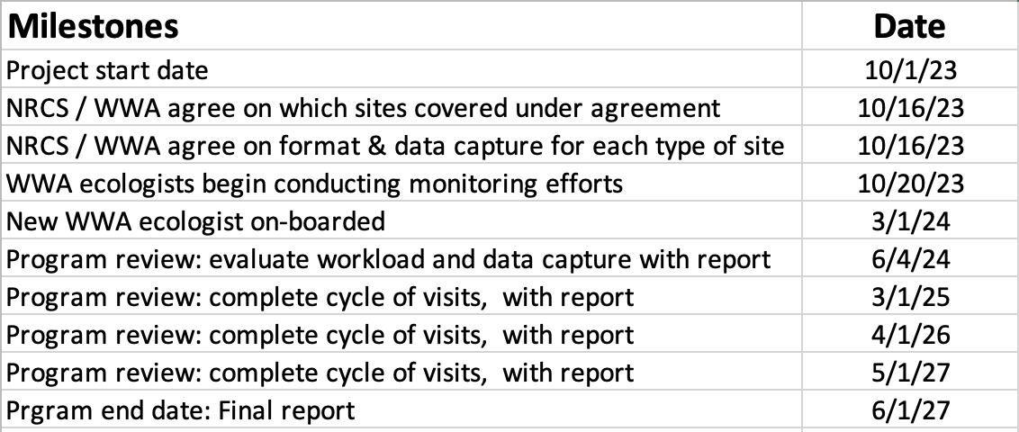
No later than 2 weeks after the project start date of 1 October 2023, WWA and NRCS will agree on which Wisconsin WREP easements will fall under this program for monitoring. In addition, WWA and NRCS will agree on what ancillary data (i.e., vegetation and infrastructure survey data) will be collected, and in what format.

After those decisions are reached, WWA will engage its current workforce of three ecologists in the effort contemplated under this proposal and commence hiring/onboarding a fourth ecologist to be on board not later than spring 2024. This timing allows rapid entry into the easement effort. The program will then continue steady state until the conclusion of the program in summer of 2027.

WWA will provide monthly invoices showing the level of WWA effort on the program and amount due. The invoice package will include a summary of easements monitored and data provided for:
- Specific easements monitored and compliance results.
- Results of vegetation assessment, restoration plan and cost estimates.
- Results of infrastructure survey, maintenance required and cost estimates.
These results will also be shared with the technical representative.

Within 30 days of each site visit, WWA’s ecologists will submit a report in the agreed format that documents site compliance, vegetation quality, and the visible infrastructure condition of the property. If warranted, there will be an accompanying remediation plan and estimated costs. This can be shared with the landowner if desired by the NRCS.

Project manager, Peter Ziegler will supervise the ecologists and oversee the program. Annual program reviews each spring will examine the current state of the program. In advance of this review, WWA will provide a report showing,
- Sites monitored since the start of the program vs goal.
- Reports generated on the vegetation quality and infrastructure condition for each site monitored.
- Problems encountered.
- Recommended adjustments to the program.

A final report in June 2027 will summarize this information with recommendations for the future.

Appendix A: Resumes of Current WWA Habitat Team

Peter Ziegler
Peter is Director of Habitat for Wisconsin Waterfowl Association. Peter has over 20 years working in the habitat restoration field across the upper Midwest. For WWA he completes property analysis, technical work, permitting, contracting and cost share associated with habitat restoration projects across the state for private landowners, non-profits, governmental agencies and commercial businesses. He has designed restoration plans for small to large wetlands, stream realignments, and associated floodplain wetlands. In the private sector he oversees all stages of restoration projects with a wide diversity of restoration activities from long term site management being completed in stages over years to shorter term projects completed within a year or less. Peter holds a BA from Luther College and has completed the following professional training related to this work: Wisconsin Wetland Restoration Workshop Conservation Delivery, 2011. Wetland Training Institute; 2009-US Army Corps of Engineers Wetland Delineation Certification and Lakeshore Habitat Restoration Training for Professionals, 2014.

ANTHONY HATCHER
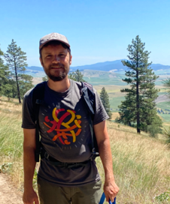
Anthony is a Public Lands Ecologist with the Wisconsin Waterfowl Association where works to identify and plan wetland restoration projects on state lands. He has over ten years of experience in natural resource conservation including diverse experience in habitat restoration, environmental monitoring, field botany, and conservation agriculture. Prior to coming to WWA, Anthony worked for a Conservation District in Washington State helping private landowners implement restoration projects and conservation agriculture practices. He holds a B.S. in Ecology and has a master’s certificate in Restoration Ecology.

MARK PFOST
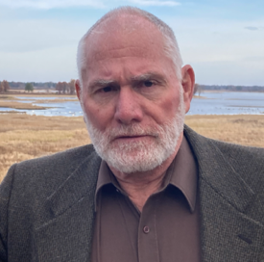
After retiring from the Navy, Mark earned degrees in geography and wildlife ecology from UW-Madison. During that time he interned with the Wisconsin Wetland Association and Madison Audubon. He then took a position with the USFWS’s Wisconsin Private Lands Office to gain habitat restoration experience. Following graduation, Mark worked as a biotech at the Upper Mississippi Wildlife & Fish Refuge in Savanna IL for two years before moving to the Rainwater Basis Wetland Management District in Nebraska. Most of his time was spent burning, controlling invasive species and restoring prairies. While working full time he earned his masters degree. After six years in Nebraska, Mark returned to Wisconsin as the Partners for Fish & Wildlife biologist based out of Necedah National Wildlife Refuge. He spent the next twelve years primarily restoring wetlands and prairies until retiring in spring of 2022.

