WWA Strategy Development (update 3/2024)

GOAL: For WWA to be motivated by a suite of strategies that collectively will increase the impact of our organization.

WHY IS THIS IMPORTANT?
- Focuses and prioritizes investments of time, effort and money.
- Attracts the right volunteers with the right interests and skills sets.
- Shows corporate sponsors, charitable foundations, and individual sponsors where their charitable interests align with WWA’s focus.
- Allows consistent evaluation of WWA effectiveness.
- Gives the Board a tool to control WWA’s direction.

BACKGROUND: Based on an organizational evaluation conducted in winter 2023, the Board embarked in January ‘24 on an effort to develop:
- A long term, clarifying vision for WWA;
- Goals and supporting metrics (or key performance indicators – KPIs) that would help determine if progress is being made towards that vision; and
- A set of Programs/Strategies to drive those metrics in the right direction.

The board, committees and staff have had an opportunity to react to the straw man vision and KPIs distributed at the last board meeting. Comments have been incorporated below. This can be considered a “working” draft.

NEXT STEPS: Directors will:
- Approve the working “vision” and its component parts, including the Goals and KPIs. (at March Board Meeting)
- Define / Describe the Programs that will achieve the vision, and the responsible committee(s) (by April Board meeting)
- With their committees: For each program, identify the next step in designing, implementing or sustaining each program. (by April Board Meeting)

WHAT “DONE” LOOKS LIKE: A published multi-year strategy document that contains a vison, defined and assigned Programs and Strategies/initiatives, with actionable goals and milestones.

WWA Vison: The Midwest’s premier state-based waterfowl hunter organization.

- EFFECTIVE ADVOCACY FOR WATERFOWLER INTERESTS: Advance policy-maker respect for waterfowler insights and contributions. WWA will be the leading voice for waterfowl hunters on hunting policy issues and for habitat-related topics important to waterfowl.
  - Increase WWA advocacy capacity and influence
    - # of policy issues for which WWA provided policy input
    - Grassroots responsiveness to action alerts (?)
    - % of policy decisions influenced to consider WWA perspective << how to measure?>>
  - <<??? seems incomplete??>>
- HEALTHY WATERFOWL POPULATIONS: Increase the numbers of ducks and geese fledged in Wisconsin by restoring suitable nesting habitat; Restore habitat beneficial to migratory waterfowl. WWA will be the state’s wetland restoration partner of choice.
  - Increase WWA’s restoration impact on…
    - … DNR-managed lands (or other = > municipal, county, federal)
      - # of sites and acres reviewed for restoration potential.
      - # of acres restored (upland and wetland)
      - Restoration specialist effort available (or committed)
      - Funding committed by partners ($)
        - Grants ($ and numbers)
        - Program Service fees ($ and numbers)
    - … Private lands (including non-government non-profit landholders)
      - # of sites and acres reviewed for restoration potential.
      - # of acres restored (upland and wetland)
      - # of easements maintained with management plans developed
      - Funding committed by partners ($)
        - Grants ($ and numbers)
        - Program Service fees ($ and numbers)

  - Expand the quantity of woods duck fledglings
    - # of wood duck boxes maintained & wood ducklings produced
    - # of wood duck boxes sold
  - Expand volunteer opportunities for meaningful habitat improvement
    - # of AWA-like projects
    - # Hours of volunteer effort
  - Funding committed by partners for education mission
    - Grants ($ and numbers)
    - Program Service fees ($ and numbers)

- PROGRESSION ALONG THE WATERFOWLER’S ARC. Provide broad and high quality waterfowling education programs through the Waterfowlers Academy ©.
  - Increase the number of novice waterfowlers through WWA introductory programs
    - # of introduction to waterfowling programs (formal LTH, individual mentors, other WWA-sponsored introductions)
    - # of new waterfowl hunters
    - Diversity of new waterfowlers
  - Monthly Newsletter
    - # subscribers
    - Open rate %
    - Click through rate %
  - Expand Waterfowl Hunters EXPO
    - # of attendees
    - # education activities and participation (seminars,
    - Diversity of attendees
  - Advance Waterfowl-Related Research and Scholarship
    - # of research initiatives and funding provided
    - # of schools using Wood Duck Curriculum
    - # of scientific products and grant $ awarded
    - # of future waterfowl professionals mentored and $ scholarship awarded
  - $ received for education programs

- MEMBERSHIP AND VOLUNTEERISM: Attract and retain the most committed waterfowlers across the state.
  - Increase membership
    - # of members; retention %
    - % of state waterfowlers
  - Increase volunteers
    - # of volunteers; retention
    - # of chapters
    - Activities per chapter
  - Expand Social Media followership
    - # of page followers, trend
    - # of group members, trend
  - Increase member willingness to support WWA
    - Grass roots membership dollars (by membership type)
    - Number of major/significant donors and $

- SUSTAINABILITY: Through well-diversified revenue streams, expand WWA impact through top quality programs, engaged well-directed volunteers and a motivated, efficient staff.
  - Maintain a balanced portfolio of revenue streams
    - % Event income (chapter, state, and EXPO)
    - % Membership, Donor income
    - % Corporate Sponsor revenue
    - % Program service fees (Private and public lands, R3, etc)
    - % investment income
  - Exceed Better Business Bureau’s standards for efficiency
    - Program Expenses – Spend > 65% of expenses on programs
    - Fundraising – spend < 35% of contributions on fundraising
  - Expand endowment fund’s ability to sustain and expand WWA
    - $ of endowment growth
    - Interest income through endowment
    - Expand Planned giving receipts
  - Maintain or exceed NGO pay parity
    - Within 10% of comparable NGO benchmarks
  - Integrated and efficient use of technology

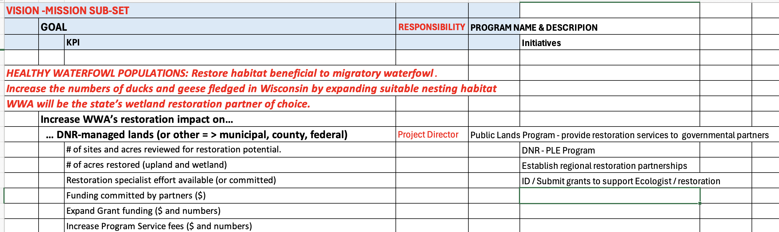
Habitat example (To be discussed)

Themes for this first WWA strategic plan
- This effort is years in the making and iterative. Goals will be re-described/refined when we realize a goal was incompletely or inaccurately described, or that we are focused on activities, to the exclusion of results; KPIs will undergo change when it is realized that we have no way of capturing the data; Data may go uncaptured for periods without the tools needed to efficiently harvest that data. That’s OK.
- There is insufficient staff to accomplish all Programs needed to achieve this vision. There are insufficient volunteers to achieve this vision. WWA should work along the path of incremental professionalization of programs. Nevertheless, there should always be impactful roles for volunteers as that is a hallmark of WWA
- Finding the right leverage point is necessary to maximizing WWA impact. This means that WWA’s impact will be greater as a leader in partnerships, not operating in isolation.
- Financial reserves have improved, but WWA is still a hand-to-mouth organization. This creates sustainability risk for sustainability, of course. But it also limits opportunities where cash flow constraints prevent undertaking reimbursable Programs.
- Most of these goals are targeting effectiveness over efficiency… but the next level of organizational maturity must also include efficiency tracking.

In these early stages, the vision is still quite flexible until the Board agrees that it is sufficiently mature for finalizing / publishing several months from now.
… and second nationally only to California Waterfowl Association.

