Little Yellow River Watershed Restoration Project

U.S. Fish and Wildlife Service Brad Strobel - Primary Contact Wildlife Biologist
Necedah National Wildlife Refuge Necedah, WI

Jeffrey Krueger Refuge Manager
Necedah National Wildlife Refuge Necedah, WI

Josh Eash
Regional Refuge Hydrologist
U.S. Fish and Wildlife Service Bloomington, MN
Partnering Programs Meggin Weinandt Property Manager
Meadow Valley State Wildlife Area Wisconsin Department of Natural Resources Babcock, WI

Darren Ladwig Wildlife Biologist
Meadow Valley State Wildlife Area Wisconsin Department of Natural Resources Babcock, WI
Joel Clark Chairman
Kingston Township, WI

Project Description/Abstract:
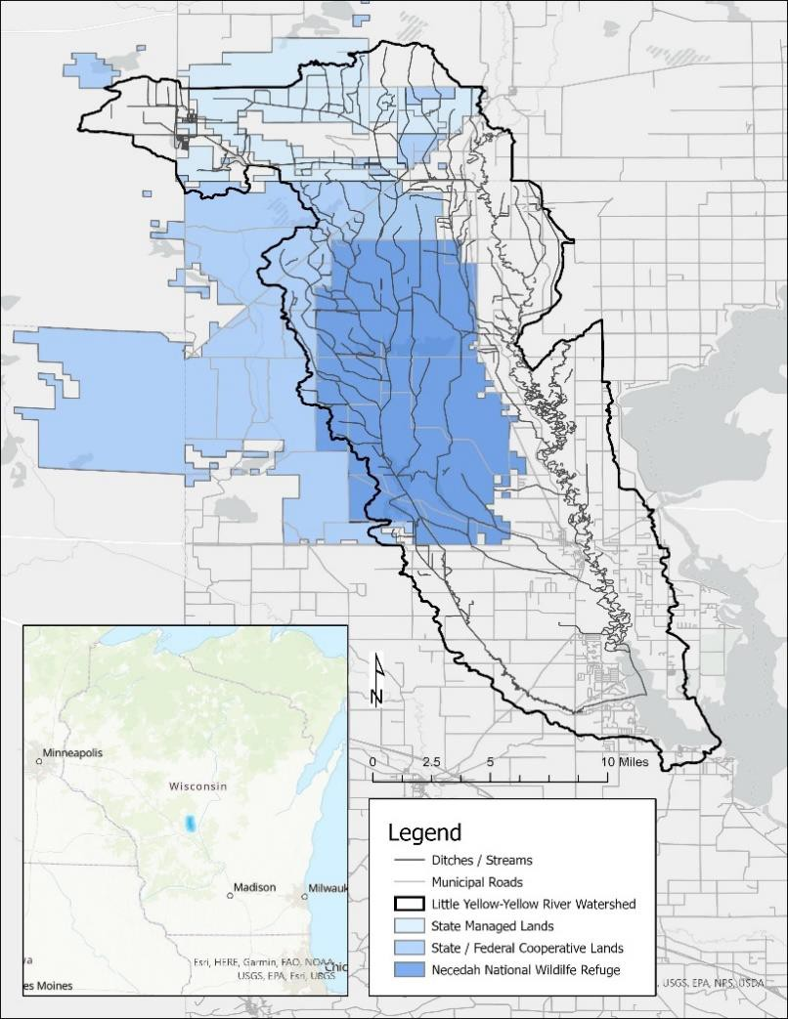
The Little Yellow River – Yellow River Watershed covers 150,000 acres in central Wisconsin, of which more than 50% of the land area are wetlands. Extensive drainage efforts during the early 20th century straightened the Little Yellow River and substantially changed the hydrology and vegetation communities of the area. The resulting ditches continue to drain wetlands and consolidate water, strain infrastructure and contribute to downstream flood damage. To date, landscape scale wetland restoration projects have not been implemented because of their potential impact to municipal transportation infrastructure. Many of these roads were created before 1920 using construction methods and materials that are not resilient to the current and future conditions. This project seeks to work collaboratively with local stakeholders to reactive the water storage potential in 30,000 acres of wetlands, restore the Little Yellow River to its former streambed, and improve the municipal transportation infrastructure to be better prepared for future storm events. Collectively, this project will enhance public access, reduced maintenance costs, and restore important ecosystem functions to the benefit of current and future generations.

Background and Justification:
From 1832-1866 the federal General Land Office conducted an inventory of the distribution, type and abundance of Wisconsin’s natural resources. Surveyor’s records included descriptions of size and species of trees, general vegetation communities and soil types. To describe the location of section corners, surveyors recorded the species and the
diameter of nearby “witness” trees. These records provide the earliest systematic account of the forest resources surrounding the current Necedah NWR. Of the 1,012 trees used as witness trees in the area, red pine (Pinus resinosa) and jack pine (Pinus banksiana) were the most frequently reported (31% and 25%, respectively) followed by tamarack (Larix laricina) and white pine (Pinus strobus; 14.4% and 13.4% respectively). Red pine, jack pine and white pine are still common to the Necedah NWR today, but tamarack is nearly absent. In 1848, the Necedah Lumber Company established a sawmill on the Yellow River at the current location of Necedah, Wisconsin. Supplied by the large white pine stands of northern Juneau County, they produced lumber from 1849 until 1892. The Necedah sawmills reportedly produced 16 million linear feet of lumber and shipped over 4000 rail cars during 1889. The intensive logging reduced the great
“Pinery” of central Wisconsin to slash piles within 40 years and paved the way for what Aldo Leopold called the “decade of the drainage dream”.
In 1900, 60,000 acres of wetlands were organized into Wisconsin’s first legal drainage district; the Little Yellow River drainage district. In the next few years, more than 300,000 acres of central Wisconsin wetlands would fall under the purview of a drainage district. Large steam dredges were used to channelize the streams and cut drainage ditches through the marshes. Roads were created to provide access to the newly drained lands and prospective farmers were lured to farm the dark peaty soils. The challenges of farming the marshes were many. Occasional high crop yields could not offset the frequent flooding, fires and frosts or the poor soil fertility and high drainage fees. Most of the farms established with the drainage district were unable to yield enough to sustain the farmer’s family let alone pay the drainage districts taxes. By 1924, the Little Yellow River drainage district was the most indebted district in the state. By the late 1930’s, most of the wetlands of central Wisconsin were held in public trust by government agencies, were removed from the Little Yellow River Drainage District and conservation efforts were initialized.
Nearly 100 years after they were dredged, much of the drainage districts original infrastructure continues to have substantial negative impacts to the vegetation communities and transportation infrastructure within the watershed. Monitoring data and literature resources shown that ditches in these soils can have lateral drainage effects beyond 1000’. The extensive drainage network has drastically increased the volume and velocity of surface waters relative to those experienced 125 years ago. Local municipalities have not had adequate resources to maintain or update the aging transportation infrastructure. Disabling drainage ditches would (1) reduce the volume and velocity of flood events, (2) reduce the variability in water elevation, and (3) restore the water levels and hydrologic patterns in forested and emergent wetlands. However, restoring the water level in wetlands would also (4) inundate portions of some municipal roads which were constructed at elevations dependent on the lower water surface elevation. It’s clear that in their current state, the wetlands, drainage ditches and transportation infrastructure are not resilient to the current and future climate conditions. However, opportunities for landscape scale solutions have been elusive.
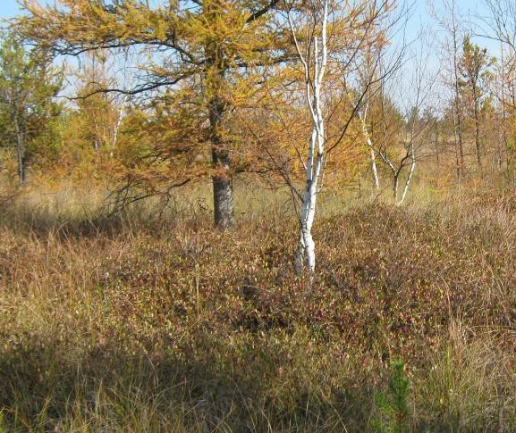
Prior to 1900, a portion of the Little Yellow River more than 15 miles long flowed through the sedge meadows and wetlands, on what is now the Necedah National Wildlife Refuge. The gently sloping and sand ridges caused the river to meander east and west nearly as much as it travelled south. The wetlands within
the Little Yellow River’s floodplain served as both sponge and filter, absorbing large flood events and sediments. Nearly a century ago steam-powered dredges dug deep ditches designed to hasten the Little Yellow River south in an effort to turn wetlands into farmlands. The waters of the Little Yellow River continue to flow straight through those ditches. This drainage network drastically altered the biological diversity, integrity, and health of the forested and emergent wetlands within the Little Yellow River watershed. Forested wetlands historically included

tamarack sedge meadows and riparian hardwood bottomland forests. Hog Island Tamaracks State Natural Area (SNA), located near the northern edge of the watershed, is one of the few remaining examples of this vegetation community. Hog Island Tamaracks features a northern wet forest of tamarack and black spruce. Low sandy ridges are interspersed within the flat plain. The shrub layer is dominated by huckleberry with winterberry and mountain holly. The herb and low shrub layer are typical of this community type and includes Canada bunchberry, swamp dewberry, cinnamon fern, and tawny cotton-grass. This peatland community provides habitat for numerous Species of Greatest Conservation Need found at their southern range limit.
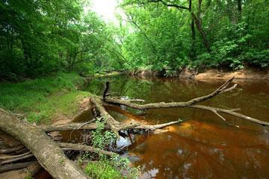
The State Natural Areas within the Yellow River’s floodplain, which is located on the eastern side of the watershed represent another forested wetland community that was historically much more common the project area. This floodplain forest community include, silver maple, green ash, swamp white oak, and river birch. Canopy associates are cottonwood, red oak, box elder, yellowbud hickory, red maple, American elm, basswood, and black ash. The low sandy ridges, slightly higher than the surrounding floodplain support white oak, bur oak, shagbark hickory, black cherry, and white pine. The presence of scattered, large, native conifers within a lowland hardwood community is unique and
rare in Wisconsin. Protection of intact stands of bottomland forest in the state is a high priority along this river corridor and opportunities are increasingly scarce on this landscape. Restoring these vegetation communities in the project area requires restoring the hydrologic conditions and meandering path of the Little Yellow River.

Project Location:
The proposed project is located on the Necedah National Wildlife Refuge and the adjacent Meadow Valley State Wildlife Area (See Map). These lands are owned by the U.S. Government and are managed by the U.S. Fish and Wildlife Service and Wisconsin Department of Natural Resources, respectively. The project area is within the congressional District 7 (Thomas Tiffany, representing) and represented by Senators Tammy Baldwin and Ron Johnson. Locally, the project area is within the municipal townships of Necedah, Cutler, Kingston, and Finley.

Project goals
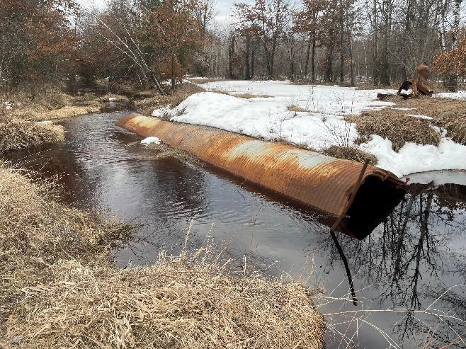
Work with our partners within the Little Yellow River’s watershed to strategically and pragmatically implement nature-based solutions that will simultaneously:

- Restore the hydrologic conditions in the emergent and forested wetland communities
- Moderate the velocity and volume of downstream flows to reduce strain on transportation infrastructure and flooding risks to downstream stakeholders.
- Reduce the conflict between beaver activity and transportation infrastructure by reducing channelized flows and guarding infrastructure that are prone to obstructions.
- Improve water quality, wetland wildlife habitat and fish passage by implementing low impact techniques to restore the

form and function of the Little Yellow River and the associated floodplain wetlands.
- Use a data-driven approach to evaluate existing
transportation infrastructure’s current sustainability and
exposure under future climate conditions.
- Improve the overall sustainability of the transportation infrastructure by the strategic discontinuance of rights-of-way that are deemed high-risk and low-value.
- Increase public access and reduce future maintenance costs by improving the condition of high-value transportation infrastructure through modern design and construction techniques that increase the resiliency to changing water levels and durability of weak road subgrade.
Water could be held in restored wetlands for sequestering
carbon instead of damaging infrastructure
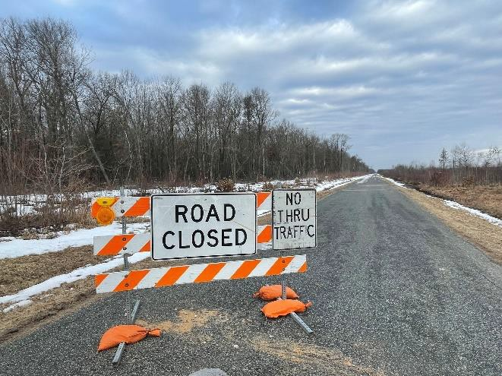
Road closures are common throughout the project area and limit public use and land management actions alike.

Expected outcomes related to climate adaptation, resilience, and mitigation.
- Rewatering the currently drained wetlands will result in increased carbon sequestration rates and reduced carbon oxidation in peat accumulating soils.
- Improvements to the conditions for forested wetlands, particularly Tamarack forests, will resist the northward range shift for this important vegetation community and the wildlife that depend on it.
- Once the hydrologic conditions are restored the wetland soils will have more precipitation storage capacity, increased evapotranspiration rates and reduced surface water outflows.
- Fewer and better transportation and water control infrastructure will be more resilient to future climate conditions and result in fewer emissions from needed maintenance.

Ecological and human community and socio-economic benefits expected
The President’s Council on Environmental Quality, Climate and Economic Justice Screening Tool shows that northern Juneau County Wisconsin (tract # 55057100100) is burdened by several disadvantages. The community is above the 65th percentile in the “low income” category and faces major energy and transportation challenges. Compared to the national average this community is above the 90th percentile in energy costs and transportation barriers. This project seeks to address those barriers directly by working with our community leaders to improve the transportation infrastructure, so it is more resilient to current and future conditions and in-turn reduce energy costs to the public.

Climate Adaptation and Resilience:
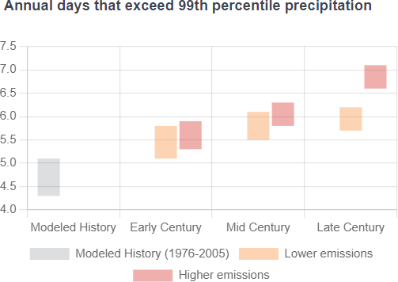
The thousands of acres of wetlands in the project area can provide important wildlife habitat and critical ecosystem services to the community. The native wetland plants of this flat landscape are adapted to high groundwater conditions and frequent flooding. However, the altered hydrology resulting from historic drainage modifications focuses the flooding risk on the water management and transportation infrastructure as well as onto downstream communities. The Climate Mapping for Resilience and Adaptation (CMRA) report (Appendix A) ranks flooding risk in the project area to be “moderately high”.

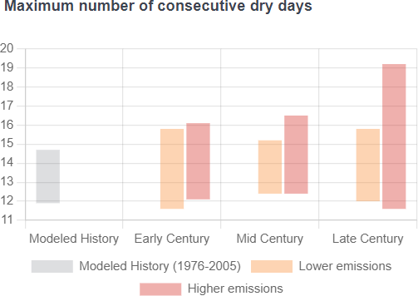
Nearly 90% of the water entering the Little Yellow River’s watershed comes as local precipitation. The CMRA tool shows that future precipitation in the area is expected to increase overall. Importantly, this precipitation is expected to be in less frequent but larger rain events.
These predictions suggest that, under there current conditions, the drained wetlands will experience longer dry periods and the maximum volume and velocity of water moving through the drainage ditches will increase during more frequent, higher intensity events. Under the current infrastructure landscape, extreme flow events will cause additional strain to the existing transportation and water control infrastructure and increase the risk of flooding to downstream communities.

This project will have several distinct benefits both mitigating and being
resilient to future climate conditions. The abilities of wetlands to store water and reduce flooding is well documented. This project will enable wetlands to capture and store more water during precipitation by strategically disabling the existing drainage on the refuge and state wildlife area. The water that currently flows through consolidated ditches will move more slowly through wetlands and the shallow groundwater system. This will reduce high flow events and allow infrastructure to pass smaller volumes of water over an extended period. This project also calls for the use of modern construction techniques to improve the resiliency of the municipal transportation infrastructure to future weather conditions and flooding events. This will require portions of the roads to be raised to a sufficient elevation above the expected groundwater and to be resistant to normal water level fluctuations. Once the transportation infrastructure is improved, they will be less frequently impacted by the unexpected obstruction caused floodings. While beaver dams frequently cause unpredictable flooding in the current ditch system, beavers are less likely to construct dams across areas with dispersed and slow-moving surface waters that would be created by this project. Finally, the restored wetlands and wetlands plants will increase the amount of water that is leaving the watershed through direct evaporation or through transpiration by wetland plants.

Project Implementation Phases
Phase 1: Headwaters Restoration and Infrastructure Resilience
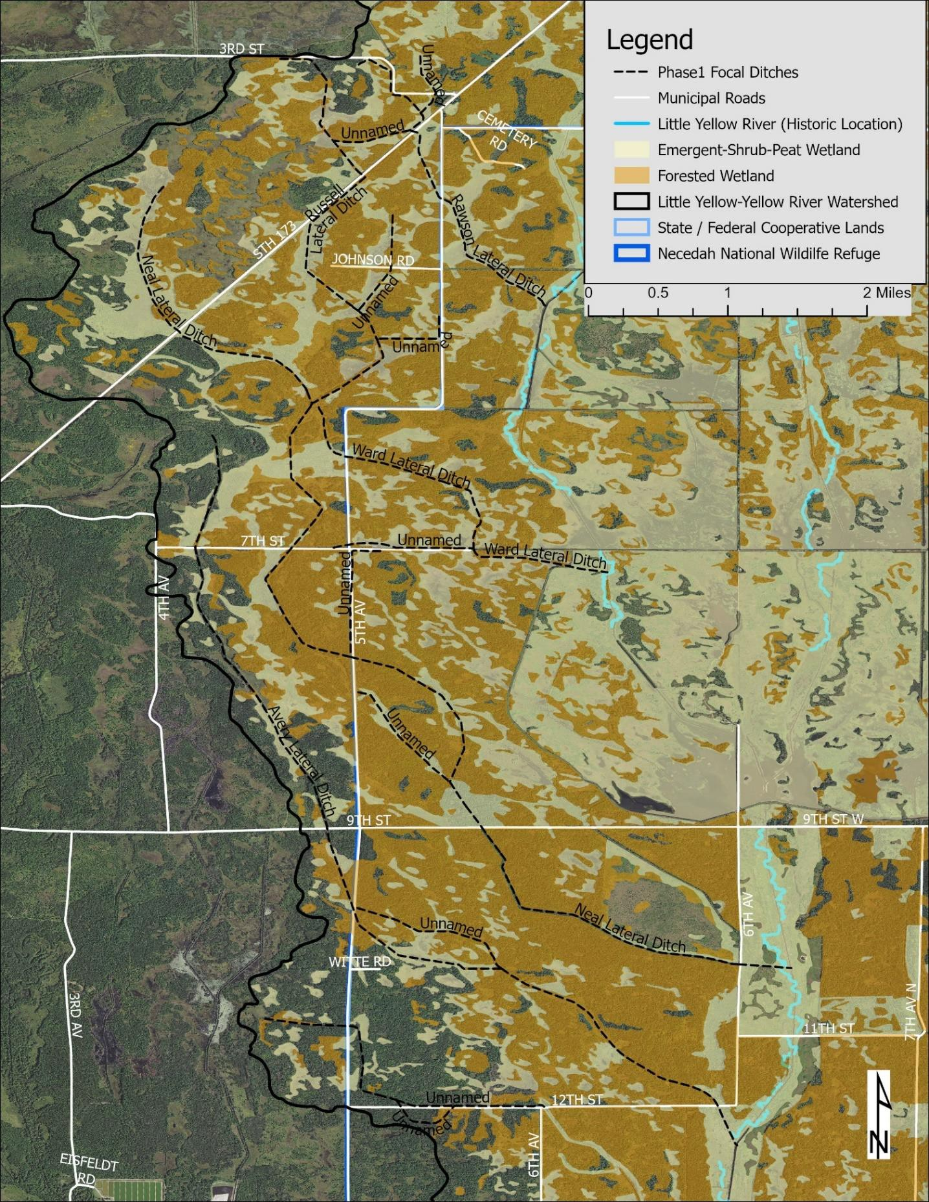

1.8 million - Design and implementation of flood resilient improvements on 7 miles municipal roads
0.4 million - Purchase and installation of improved water infrastructure
0.8 million - Design and implementation of wetland restoration structures for 30,000 acres of wetland
Total Phase Expense $3.0 million

Phase 2: Little Yellow River Restoration and Infrastructure Improvement
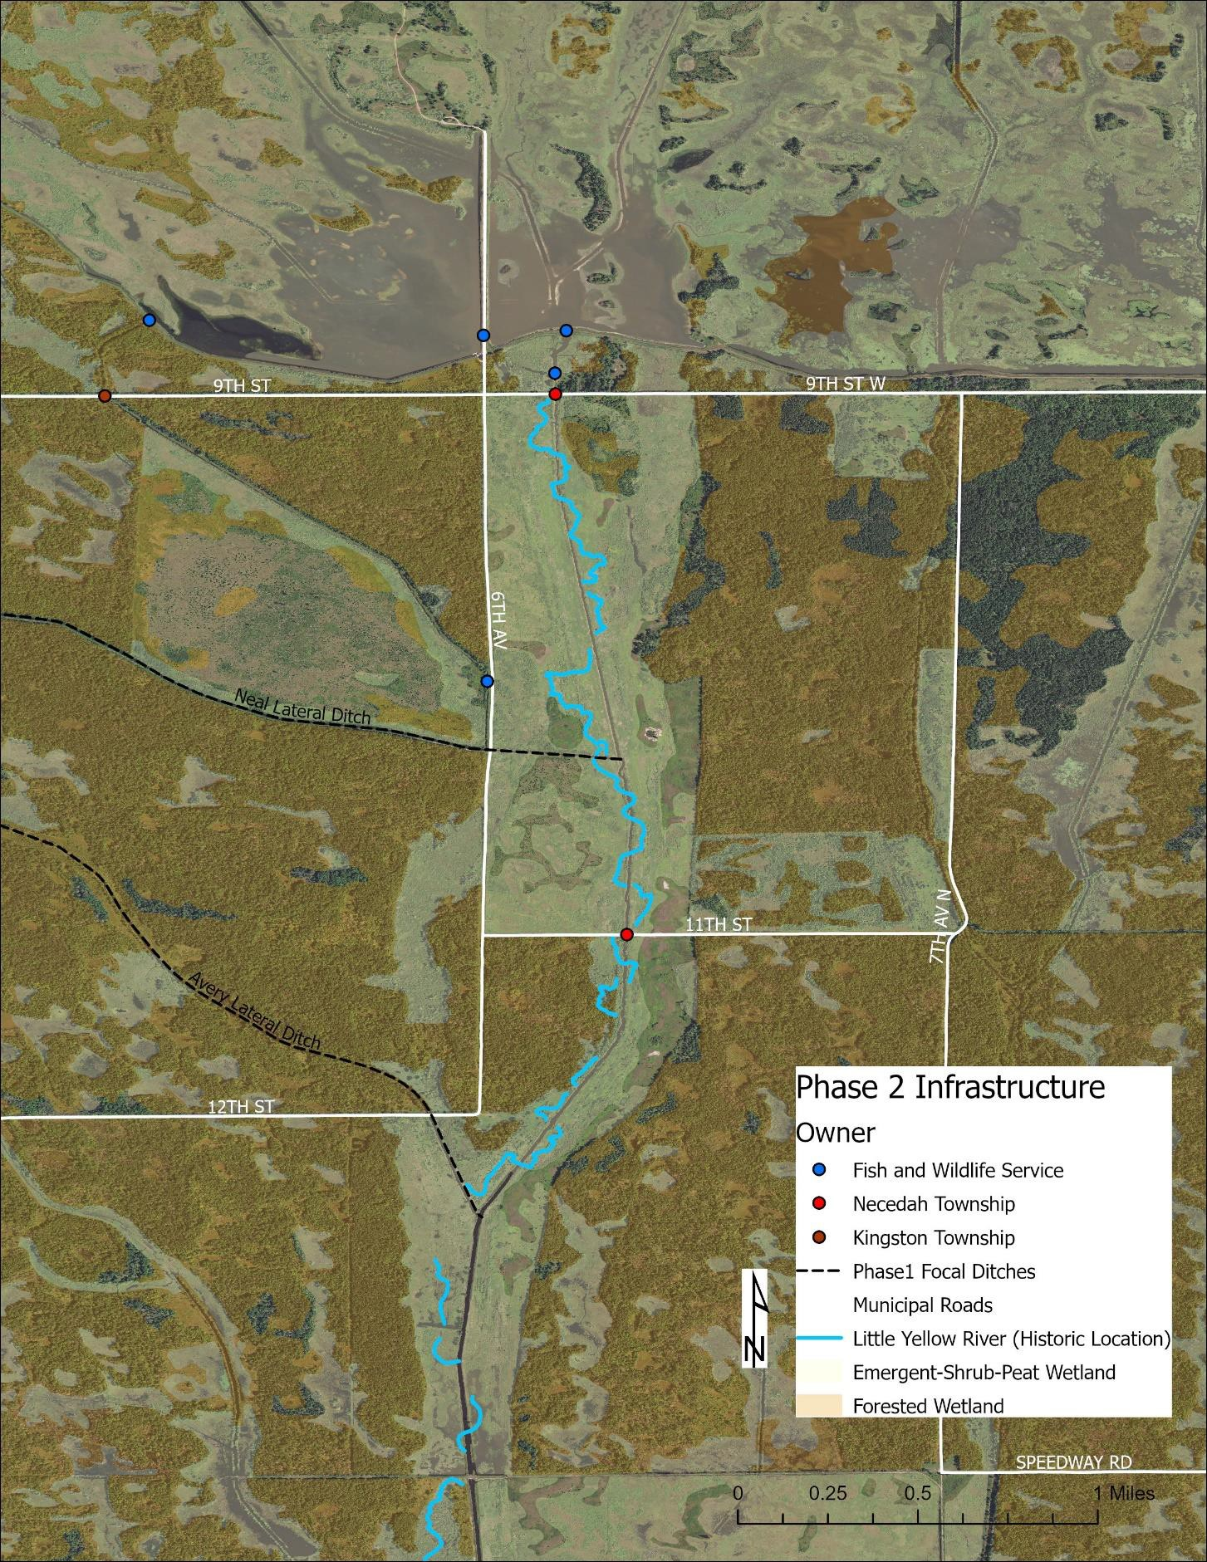
0.4 million – installation of 2 bottomless arch structures at road-river crossings
1.0 million – construction of 1 mile of flood resilient asphalt roadway
0.5 million – Design and implementation of flood resilient improvements on 2 miles of municipal road
0.5 million – removal and improvements to Refuge water management infrastructure
0.2 million – restoration of 6 miles of the Little Yellow River within the Necedah National Wildlife Refuge
Total Phase Expense $2.6 million

