
14 January 2025

From: Executive Director, WWA
To: WWA Board of Directors

Subj: Outsourcing EXPO and Marketing functions

- As part of both the EXPO’s incremental professionalization sustainment strategy and WWA’s need to expand capacity to sustain our growing operations, I am proposing to hire the Swift Waters company to perform marketing and EXPO management for WWA.
- Swift Water’s proposal is attached, laying out the functions anticipated. I suspect some items will have been unanticipated. I have confidence Shawn Gibbons will operate in the spirit of the agreement and we will adjust duties as needed. But please identify items you may see as needed but unaddressed in the proposal
- This is significant step for WWA, and it comes at a significant cost. Swift Waters proposal at $55,000, discounted $21K means that WWA must afford $34,000 for a year to embrace this step. This is possible, using a combination of R3 grant funding, JEM grant funding, WWA funding, and a performance-based shared risk/reward associated with the EXPO sponsor acquisition.
  - The table below shows the sources of funding proposed to meet this expenditure
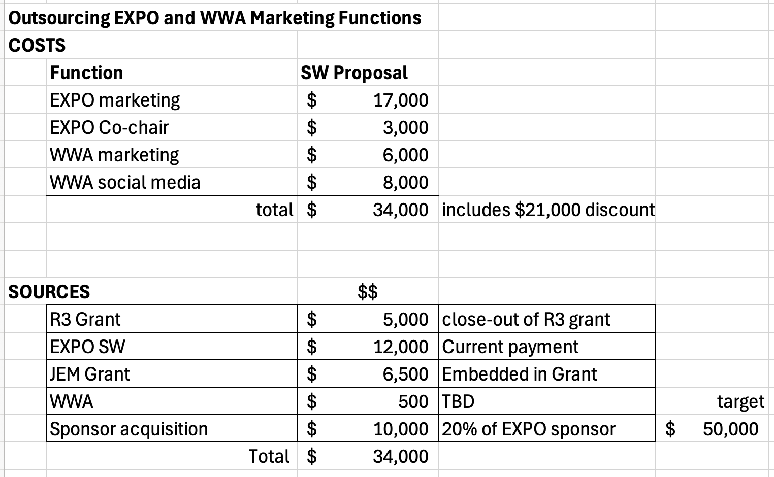

- This proposal is already incorporated into Budget (draft1), but it requires your specific approval to move forward.
- If the Board approves this proposal, it is my recommendation that Shawn Gibbons resign from the WWA board consistent with the intent of WWA’s Conflict of Interest policy. I further recommend that Connie Markham be permitted to remain on the Board if she wishes, but recused from decisions concerning the management of the Swift Waters relationship. Shawn should continue to attend as an invited guest without voting privileges in order to stay abreast of WWA happenings to fulfill his marketing duties

Bruce

Attachment Proposal with description of duties

Wisconsin Waterfowl Association and the Waterfowl Hunters EXPO Marketing Services
Swift Waters is excited to present a comprehensive Marketing Services proposal tailored specifically for the Wisconsin Waterfowl Association and Waterfowl Hunters EXPO. Our proposed services encompass a range of strategic initiatives, including Social Media Management (FB/IG), Email campaigns, Website updates, Creating and managing paid advertisements, and more. We are enthusiastic about the prospect of collaborating with you to enhance the visibility and success of the Waterfowl Hunters EXPO and the Wisconsin Waterfowl Associiation. The proposed agreement is slated to commence on 20 January 2025.

Wisconsin Waterfowl Association, including the Waterfowlers Academy:
- Marketing management
  - Marketing to support membership drive, annual calendar creation and sales support (creating and managing paid ads and newsletters).
  - Social media management, website management
- Social Media Servicies (WWA & Academy)
  - Facebook – Instagram
    - Post relevant images and videos.
      - 7 posts per week – Facebook per site
      - 7 posts per week – Instagram per site
      - Tagged for target preferred audience and business partner (maximizing SOE)
      - Post content will consist of 80% lifestyle imagery and 20% product promotion.
      - Will include WHE Logo as needed.
    - Event Management
      - Product Giveaway = budget 2 giveaways (sponsor provides product)
      - Weekly event i.e., Budget 4 interactive activities conducted on-line.
    - Cross Promotion Facebook /Instagram to business pages and groups
      - All relevant posts are “Shared” with Swift Waters and its affiliates.
    - Post Boosting (TBD)
      - Provide post boosting as part of the social media services.
    - Managing social media messaging and private messages (FB & IG). The service will be fully staffed M-F business hours and worked after hours as available.
    - Promotional content generation
      - Swift Waters will create promotional “in the field” content. Will also use Customer Generated Content “CGC.”
    - Engage as possible, or support the engagement, of social media or other influencers WWA seeks to partner with in the advancement of their missions.
- Content management:
  - Establishing, creating, housing, distributing all aspects of the WWA branding, videos, infographics, messaging, copy & creatives.
  - The content will be used to promote the overall business objective to grow the WWA event attendance, sponsorship, exhibitors as well as membership, and support other revenue generation initiatives.
  - The content will be consistent with the WHE and WWA Branding
  - The content will be tailored for each marketing channels technical specifications (newsletter, social posts, paid ad, sell sheet…).
- Website Management and Support
  - Swift Waters will backup WWA internal website support.
  - Swift Waters can perform minor updates, product page content, image updates.
  - Swift Waters will provide monthly website analytics for consumption by staff and board, while training the administrative director in how to do this routinely.

Waterfowl Hunters EXPO Main activities:
- Co-Chair:
  - Take day-to-day management responsibility from the Chair of the Waterfowl Hunters EXPO.
- Marketing Committee
  - Lead and be a major contributor team member.
  - Provide monthly updates to the WHE Steering Committee
- Managing the approved marketing budget
  - Identify and allocate the approved marketing budget over multiple distribution channels.
- Managing earned media
  - Swift waters will coordinate, facilitate and track earned media generated by all of the members of the steering committee (and any others that identify / generate earned media)
- Social Media Services
  - Facebook – Instagram
      - Post relevant images and videos.
        - 14 posts per week – Facebook per site
        - 7 posts per week – Instagram per site
        - Tagged for target preferred audience and business partner (maximizing SOE)
        - Post content will consist of 80% lifestyle imagery and 20% product promotion.
        - Will include WHE Logo as needed.
      - Event Management
        - Product Giveaway = budget 2 giveaways (sponsor provides product)
        - Weekly event i.e., Budget 4 interactive activities conducted on-line.
      - Cross Promotion Facebook /Instagram to WWA business pages and groups
        - All relevant posts are “Shared” with Swift Waters and its affiliates.
      - Post Boosting (TBD)
        - Provide post boosting as part of the social media services.
      - Managing social media messaging and private messages (FB & IG). The service will be fully staffed M-F business hours and worked after hours as available.
      - Promotional content generation
        - Swift Waters will create promotional “in the field” content. Will also use Customer Generated Content “CGC.”
  - Content management:
  - Establishing, creating, housing, distributing all aspects of the WHE branding, videos, infographics, messaging, copy & creatives.
  - The content will be used to promote the overall business objective to grow the WHE attendance, sponsorship, and exhibitors.
  - The content will be consistent with the WHE Branding
  - The content will be tailored for each marketing channels technical specifications (newsletter, social posts, paid ad, sell sheet…).
- Website Management and Support
  - Swift Waters will manage and perform the following activities on the WHE website.
  - Perform all IT and security updates necessary to keep a well-managed secure website.
  - Perform relevant event and program updates to support the WHE 24 event.
  - Create, secure, manage all content for the upcoming WHE 2024 event.
  - Swift Waters can perform minor updates, product page content, image updates…
- Digital Ad campaign (Google, Facebook / Instagram, OTT Streaming)
Each Digital ad campaign will focus on a specific marketing event (driving traffic, increase brand awareness, retargeting audiences…). Swift Waters will provide the creation, publication and monitor / optimize the ad. Swift Waters will also work with WHE to align with any other planned or ongoing marketing efforts i.e., WWA, WA, WDNR, Exhibitors, Sponsors...
This will include:
    - Swift Waters to perform ad creation and publication: Ad positioning, creation of campaign target audience, establish daily spend targets, manage Ad submission and managing to Google / FB policies and monitoring the Ad performance (based on agreed KPI’s).
    - Ad Monitoring & Optimization
      - All ad maintenance and updates (adhering to Google / FB policy changes and reviews)
      - Refresh ad content monthly based on performance (image, adjust promo price, product…)
- Podcasts
    - Swift Waters will coordinate a master podcast schedule. The Podcasts will be promoted through WHE and its affiliates. (FB, IG, Newsletters, social media & Paid Promotion)
- Traditional Marketing
  - Advance Ticketing
    - Managing the TicketSpice ticketing application. Working with designated WHE leads to effective support and implementation of the solution. Making sure that the right equipment is on site to accept customers at the door.
    - The goal this year is to create a means to find out where our attendees are coming from, specifically the walk up. This may include a door price giveaway…
  - Email Campaign
- Initial system setup: fully set up 3rd party email solution i.e., Constant Contact. Export and import leads (emails) to make the list as current as possible.
- Creation of email campaign includes building the campaign, managing test runs, publication submission and approval, establishing distribution schedule.
  - Radio
- Swift Waters will coordinate a master radio schedule. The radio will be promoted through WHE and its affiliates. (FB, IG, Newsletters, social media & Paid Promotion)
  - TV Broadcast
- Make certain that local stations will allow Public Service Announcements and investigate paid ad placements.
- This would include all messaging and video promotions that meet the broadcaster’s specifications.
  - Billboards
- Investigate and create a proposal to utilize local billboards in Fox Valley to promote the WHE.
- This will include providing consistent messaging and images for the billboard.
  - Public Relations:
- This is the first year that the WHEXPO has a notable influencer signed up to be present at the show. Although we do have several large name exhibitors.
- We will want official communications from the vendors and or individuals to promote their presence. This will be published via WHEXPO communication channels but also its affiliates. i.e., Press Releases, Media Kits, PR Events
- i.e. Banded, WDNR, BOSS Shot, Vortex…
Swift Waters would like to extend my gratitude for having the opportunity to give back to the Waterfowl community in a meaningful way.

- WHE = $20,000 - Value $30,000
- Marketing: Manage and execute all marketing and sales activities, to include upselling existing sponsors - $17K (+5K lift from 2024)
- Co-Chair: Take day-to-day management responsibility for managing the Waterfowl Hunters EXPO - $3K

- WWA =$14,000 – Value $25,000
  - Marketing management: i.e. calendar, membership drive, $6,000.
  - Social media management (WWA & Academy), website management $8,000.

- All the above = $34,000 value $55,000.
- The parties are agreed that payment will be based on a flat rate of $2,000 ($24,000 annnually) plus a shared risk/reward approach of twenty percent (20%) of all sponsorship fees acquired for the Waterfowl Hunters EXPO, payable upon the next month after receipt of EXPO sponsor funds. This does not include any additional floor space procured by a sponsor or accelerated marketing fees paid for by a sponsor.
Thank you for considering Swift Waters for your marketing needs.

____________________________
Shawn Gibbons Date Bruce Ross Date
Swift Waters Waterfowl Hunters EXPO
Owner Chairperson

