September outreach/support campaign
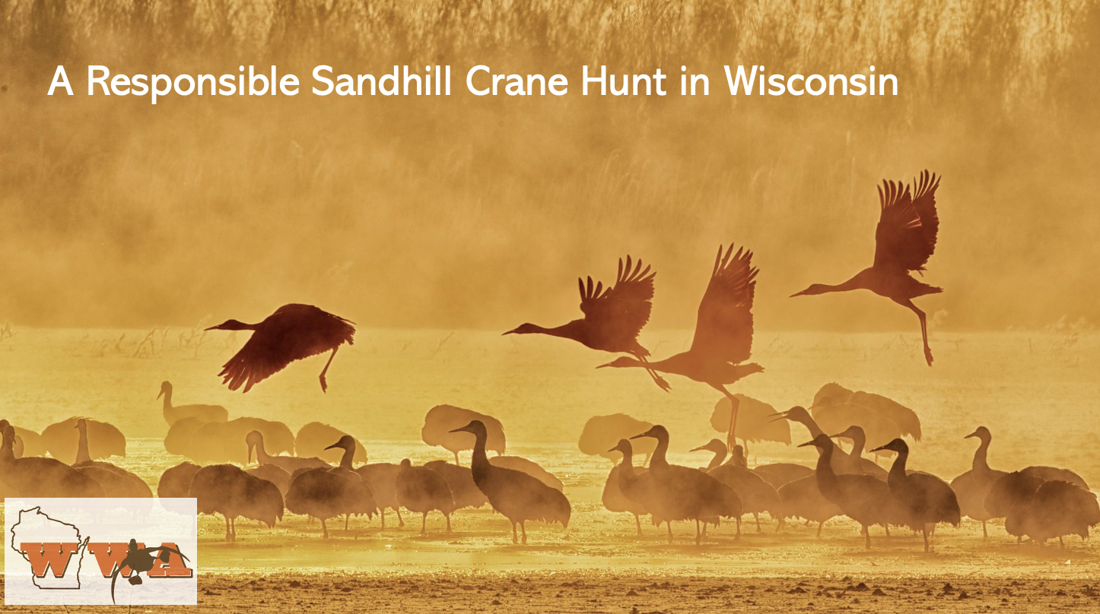
Part 1: A Responsible Sandhill Crane Hunt in Wisconsin
Part 2: Sandhill Cranes in Wisconsin
Part 3: Your Hunting Rights in the Crosshairs
Part 4: What can you do?

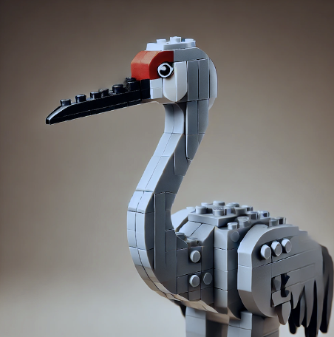
PART 1: A responsible sandhill crane hunt in Wisconsin
For the third time in 12 years, a bill to establish a responsible sandhill crane hunt is advancing though the state legislature. But it will stall yet again without your active help. And if it fails, it has negative consequences for your constitutional right to hunt. This is the first in a four-part series focused on WWA’s work to establish a responsible sandhill crane hunt in Wisconsin.
The sandhill crane population that visits Wisconsin has grown to far exceed the maximum goal set by the continent’s crane population managers, the US Fish and Wildlife Service (USFWS). With over 110,000 cranes in the population, they encourage states to undertake a crane hunt consistent with international agreements.
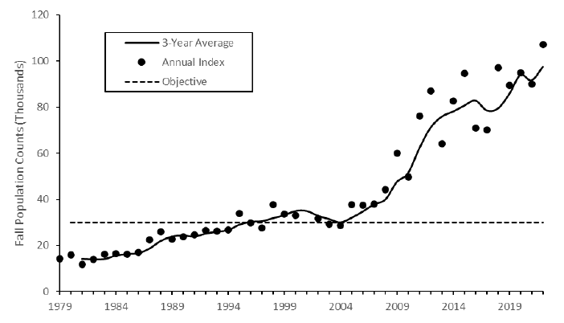
These crane experts conduct annual population counts and adjust harvest levels based on the latest science. This approach ensures crane population health is safeguarded from over harvest and naturally caused losses from diseases like bird flu.
Nevertheless, anti-hunters are making emotional appeals, promoting incomplete “science”, and generating polls of poorly informed respondents to scare Wisconsin politicians away from joining the 17 other states that hunt sandhill crane--now for over 60 years.

Who’s telling ‘the rest of the story’ to these legislators and publicly challenging anti-hunters?
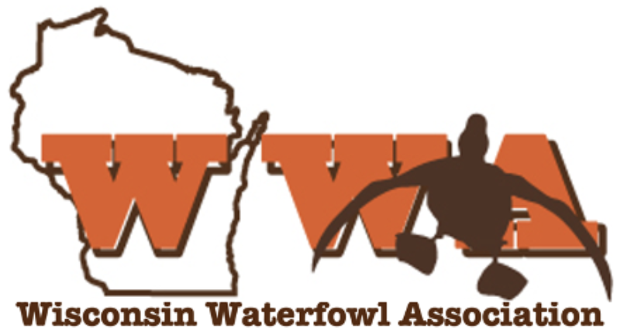

Coming up: How the growing sandhill population is causing problems and why a responsible hunt under USFWS guidelines can help.

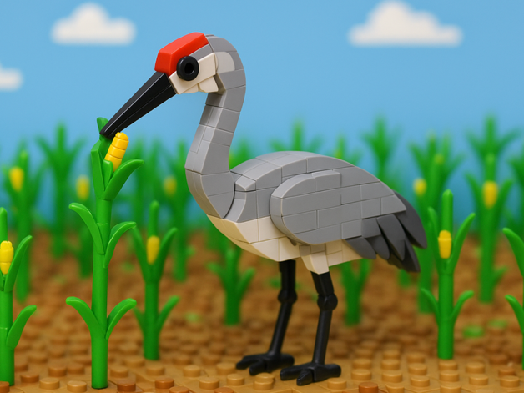
Part 2: Sandhill crane challenges in Wisconsin
For the third time in 12 years, a bill to establish a responsible sandhill crane hunt is advancing though the state legislature. But it will stall yet again without your active help. And if it fails, it has negative consequences for your constitutional right to hunt. This is the second in a four-part series focused on WWA’s work to establish a responsible sandhill crane hunt in Wisconsin.
The population of cranes that visit the Wisconsin has grown dramatically in the past 40 years, far exceeding federal population targets. That growth has also cost farmers millions.
Cranes damage Wisconsin corn, potato, and other crops, causing $2 million in damages. Another $2 million is spent by farmers for a chemical coating that prevents cranes from eating freshly planted corn. That’s a total of $4 million, a figure that grows with the growing crane population. Every single year.
And every single year, over 1400 cranes are killed under federal depredation permits and must left to rot. That’s a waste of over 10,000 highly prized game birds in the last decade. Hypocritically, anti-hunter groups have done nothing to offset farmer costs of chasing cranes from their fields, when their help could have avoided wasting many of these birds.
Working with legislators, WWA fashioned a bipartisan legislative study group that included citizen farmers to examine these Wisconsin crane issues. Their recommendations include the establishment of a crane hunt to will help control the population, while minimizing the waste of cranes killed under depredation permits. By establishing a responsible crane hunt, farmers will also be eligible for hunter-supplied crop damage funding.

Who’s advancing win-win management approaches for Wisconsin’s sandhill crane challenges?

Coming up: How opponents to a crane hunt are actively undermining your constitutional hunting rights.

Part 3: Your hunting rights in the crosshairs
For the third time in 12 years, a bill to establish a responsible sandhill crane hunt is advancing though the state legislature. But it will stall yet again without your active help. And if it fails, it has negative consequences for your constitutional right to hunt. This is the third installment of a four-part series focused on WWA’s work to establish a responsible sandhill crane hunt in Wisconsin.
Wisconsin citizens have a constitutional right to hunt that was established only 22 years ago by 82% voter approval. This vote recognized the hunting heritage of the state and disproportionate hunter contributions to conservation.
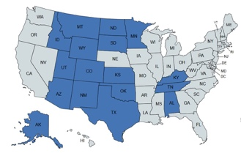
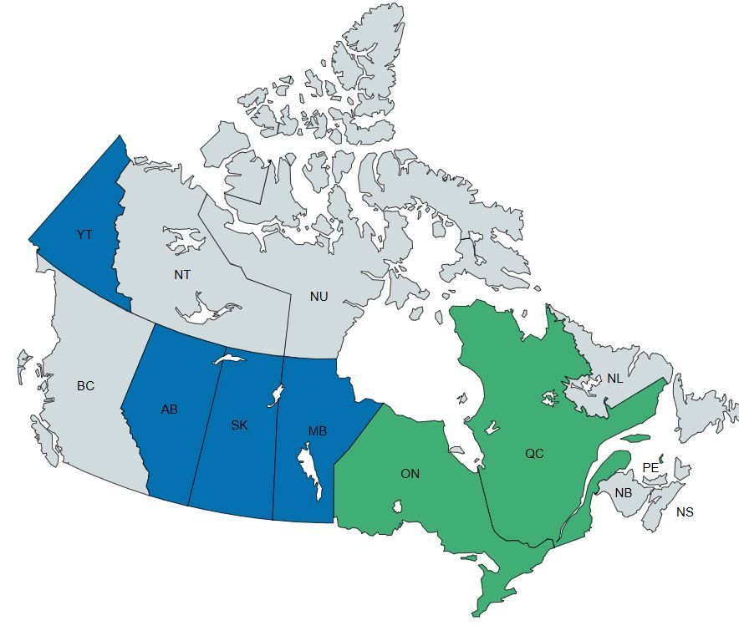
This constitutional right is limited only by “reasonable restrictions contained in law”. Such restrictions might be the duration of a season, number of birds harvested, closed areas, etc. But there are no such laws that would preclude a sandhill crane hunt in Wisconsin. Indeed, the federal managers are supportive of a crane hunt here, like happens in 1/3 of these United States.
Blue: Currently hunted Green: Planned by 2026
For 5 years, WWA has been educating legislators and promoting win-win solutions to our crane challenges. But now with a bill working its way through the legislature, we face stiff opposition by anti-hunters – and legal issues are coming to the forefront.
Wisconsin’s Supreme Court says the DNR has the authority to declare the crane a “game species”, and the Conservation Congress has voted three times to recommend establishing a hunt. But the DNR claims they need guidance from the legislature. And those politicians haven’t provided that guidance, perhaps giving weight to anti-hunter appeals. These are the same politicians who took an oath to uphold the state Constitution as they entered office.
To the degree these anti-hunter arguments are given any weight by politicians, your hunting rights are undermined.
Who’s working in Madison to protect your hunting rights?

Next week: How your active support is necessary to support a responsible sandhill crane hunt.


Part 4: WWA needs your help. NOW.
For the third time in 12 years, a bill to establish a responsible sandhill crane hunt is advancing though the state legislature. But it will stall yet again without your active help. And if it fails, it has negative consequences for your constitutional right to hunt. This is the third installment of a four-part series focused on WWA’s work to establish a responsible sandhill crane hunt in Wisconsin.
Forty-one years ago, the Wisconsin Waterfowl Association was formed by a man angry at Madison politicians who were not listening. It feels that way right now.
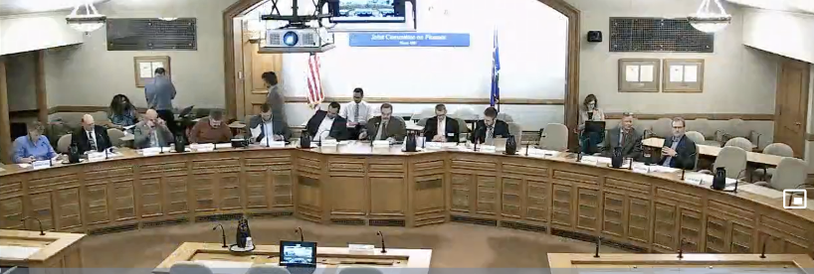
Despite:
- The science-based safeguards in a federally managed sandhill crane hunt, exemplified in over 17 states and 5 provinces.
- The population control benefits of a responsible crane hunt.
- The growing farmer costs associated with a growing crane population and
- Wisconsin’s Constitutionally protected right to hunt…
… it’s not clear that current politicians will advance a responsible crane hunt bill .
Your help is needed NOW to support WWA’s fight. There are extraordinary costs for lobbying, educational material, and staff necessary to fight this assault on Wisconsin’s hunter rights.
